

My
Transition
Information

Welcome to Reception

Our headteacher is Mrs Emsley
Our deputy headteacher is Mrs Allingham


Next year my teachers will be:

Miss Walker
and
Miss Thorp


The other adult(s) supporting me will be:

Mrs Sykes
Mrs Sherry
Miss Isherwood


In Reception, I will have a peg to keep my coat and bag on in the cloakroom. Our cloakroom is inside the Reception classroom, near the sinks and toilets.
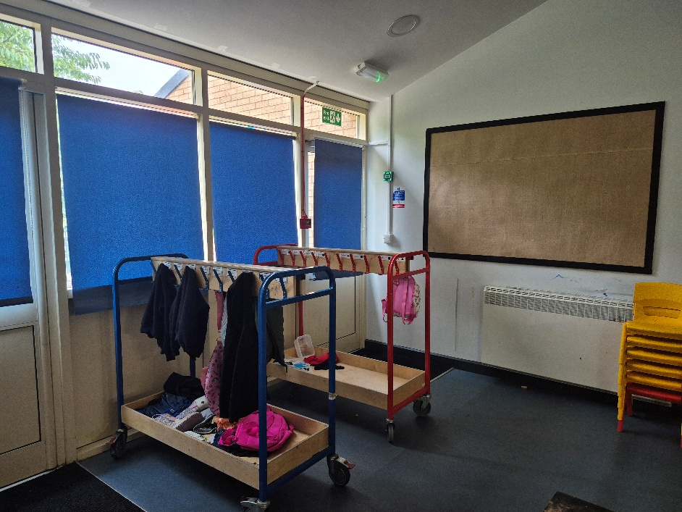

We will use the Reception toilets which are located in the classroom.
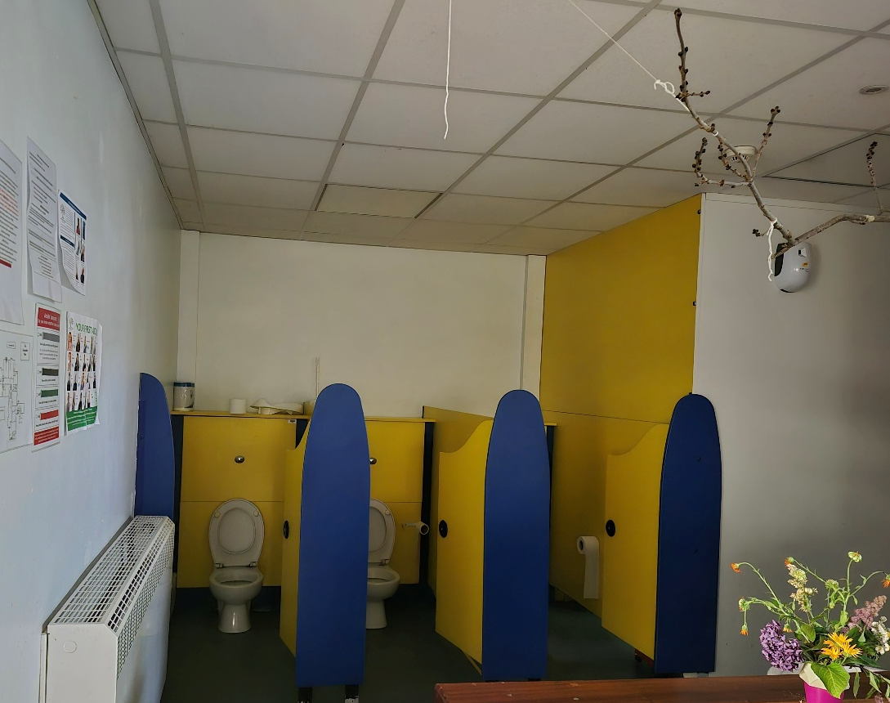

This is my classroom:

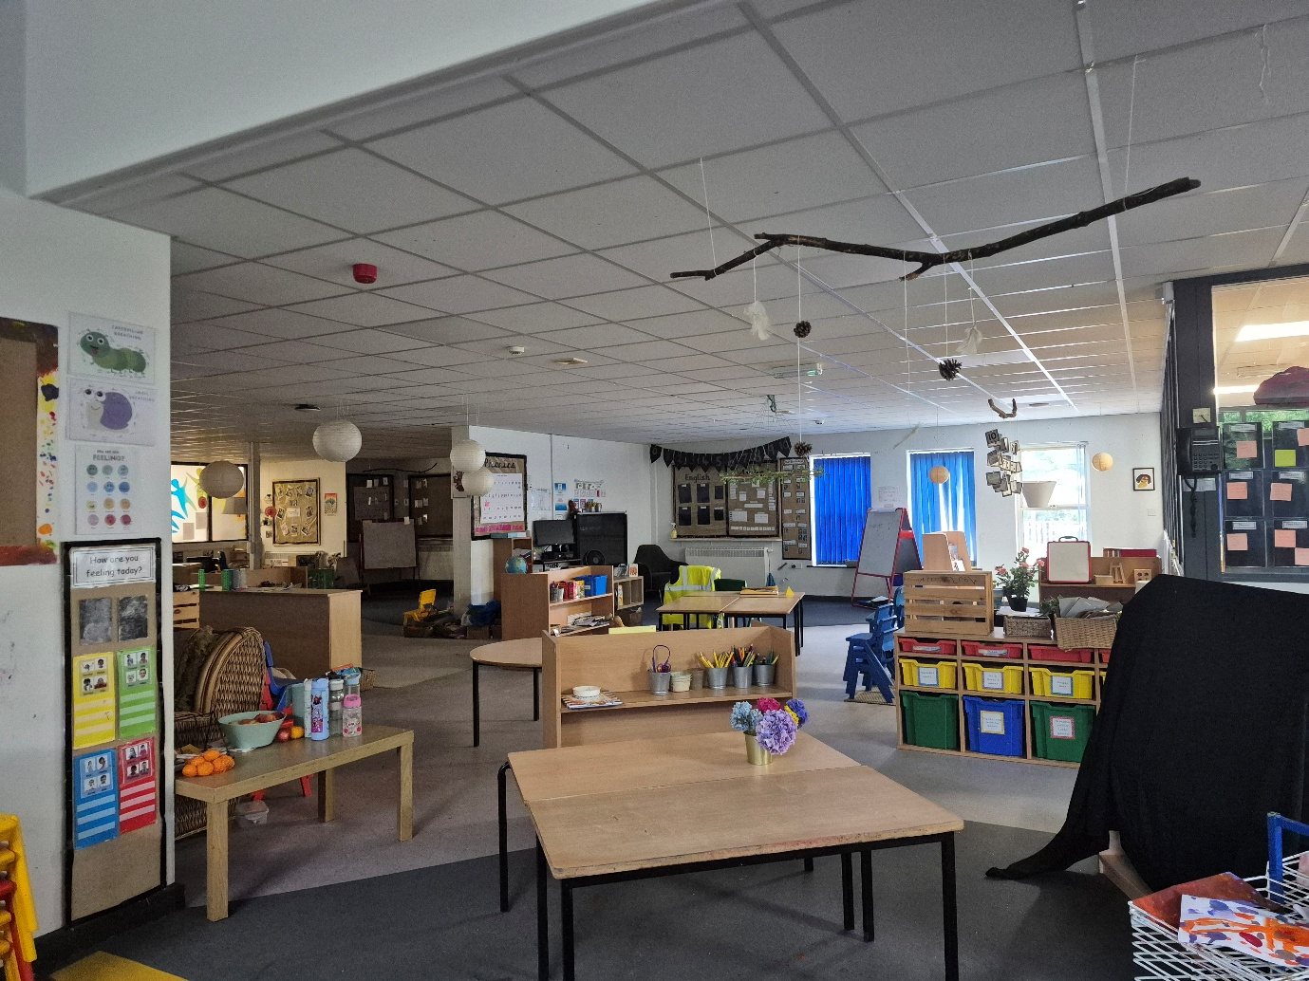
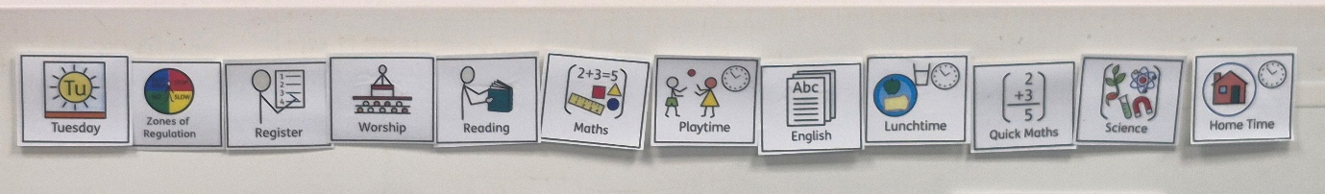
I will be able to find out what I am doing each day by looking at the visual timetable. The pictures will be the same in every class and it will be clearly visible as I look towards the board in my classroom.
On a morning, I will wait with my adult in the playground outside our classroom.
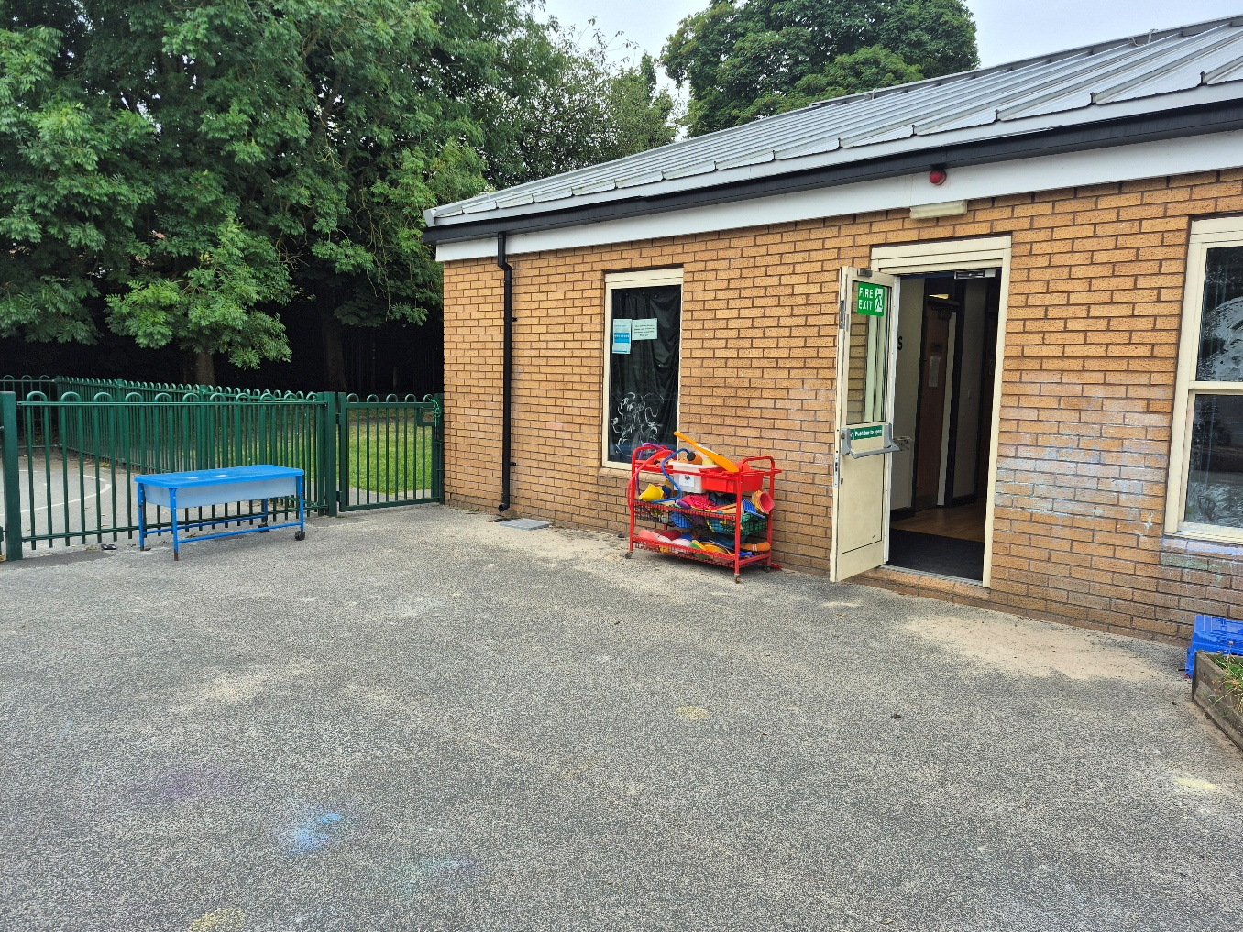

When my teacher comes to collect us, I will enter through our classroom door.
This will also be where I leave for break time and at the end of the day.

I will need to bring my water bottle every day.


I will get Dojos as rewards for good choices and good work.



We will do lots of different lessons and lots of learning through play.


We will still start our day at 8.30am and finish at 3pm.
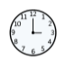
Everyone feels nervous and maybe excited when they are starting something new.

It is ok to ask questions.

It is ok to not know what to do all the time.
Adults and friends will help you. You can ask them for help or ask them a question if you are unsure about something.
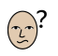
You will soon settle in and enjoy the new things that you do.

Soon it will seem like an ‘old’ classroom, not a new one!!

Well done!

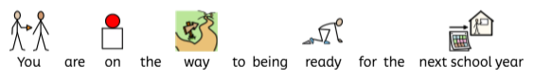
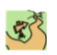
You are on the way to being ready for the next school year.

Clayton St John
'Be Ready Values'

•Be Kind and Friendly
•Be Safe and Wise
•Be Truthful and Forgiving
•Have Courage and Respect

“Give thanks the Lord, for he is good;
His love endures forever.”
1 Chronicles 16-34

“Growing Together in God’s Love”


