

My
Transition
Information

Welcome to Honey House

Our headteacher is Mrs Emsley
Our deputy headteacher is Mrs Allingham


Next year my teacher will be:

Miss Wilkinson

The other adult(s) supporting me will be:
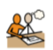
Mrs Vosper
Miss Kelly
Miss Hartley
Miss Hodgson

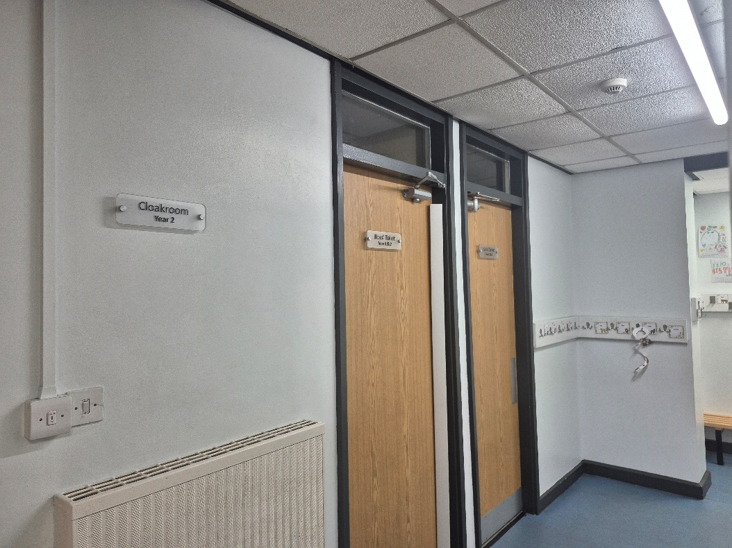
We will use the Year 1 and 2 toilets which are opposite the Honey House and Beekeepers classrooms.

Boy’s
Girl’s


This is our new Honey House – we moved just before the summer holidays:

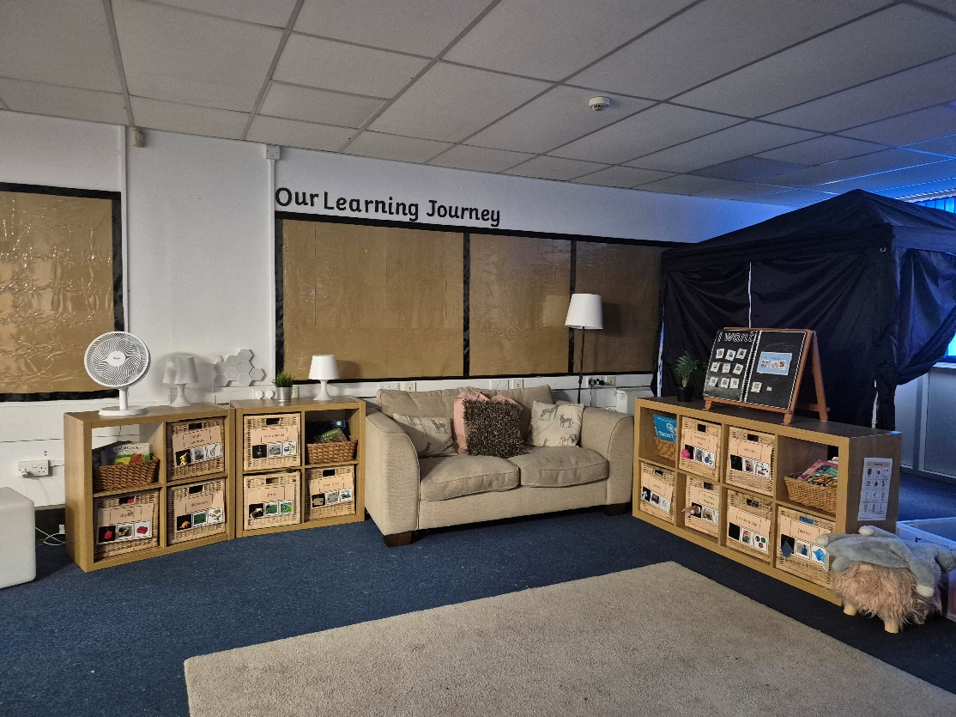
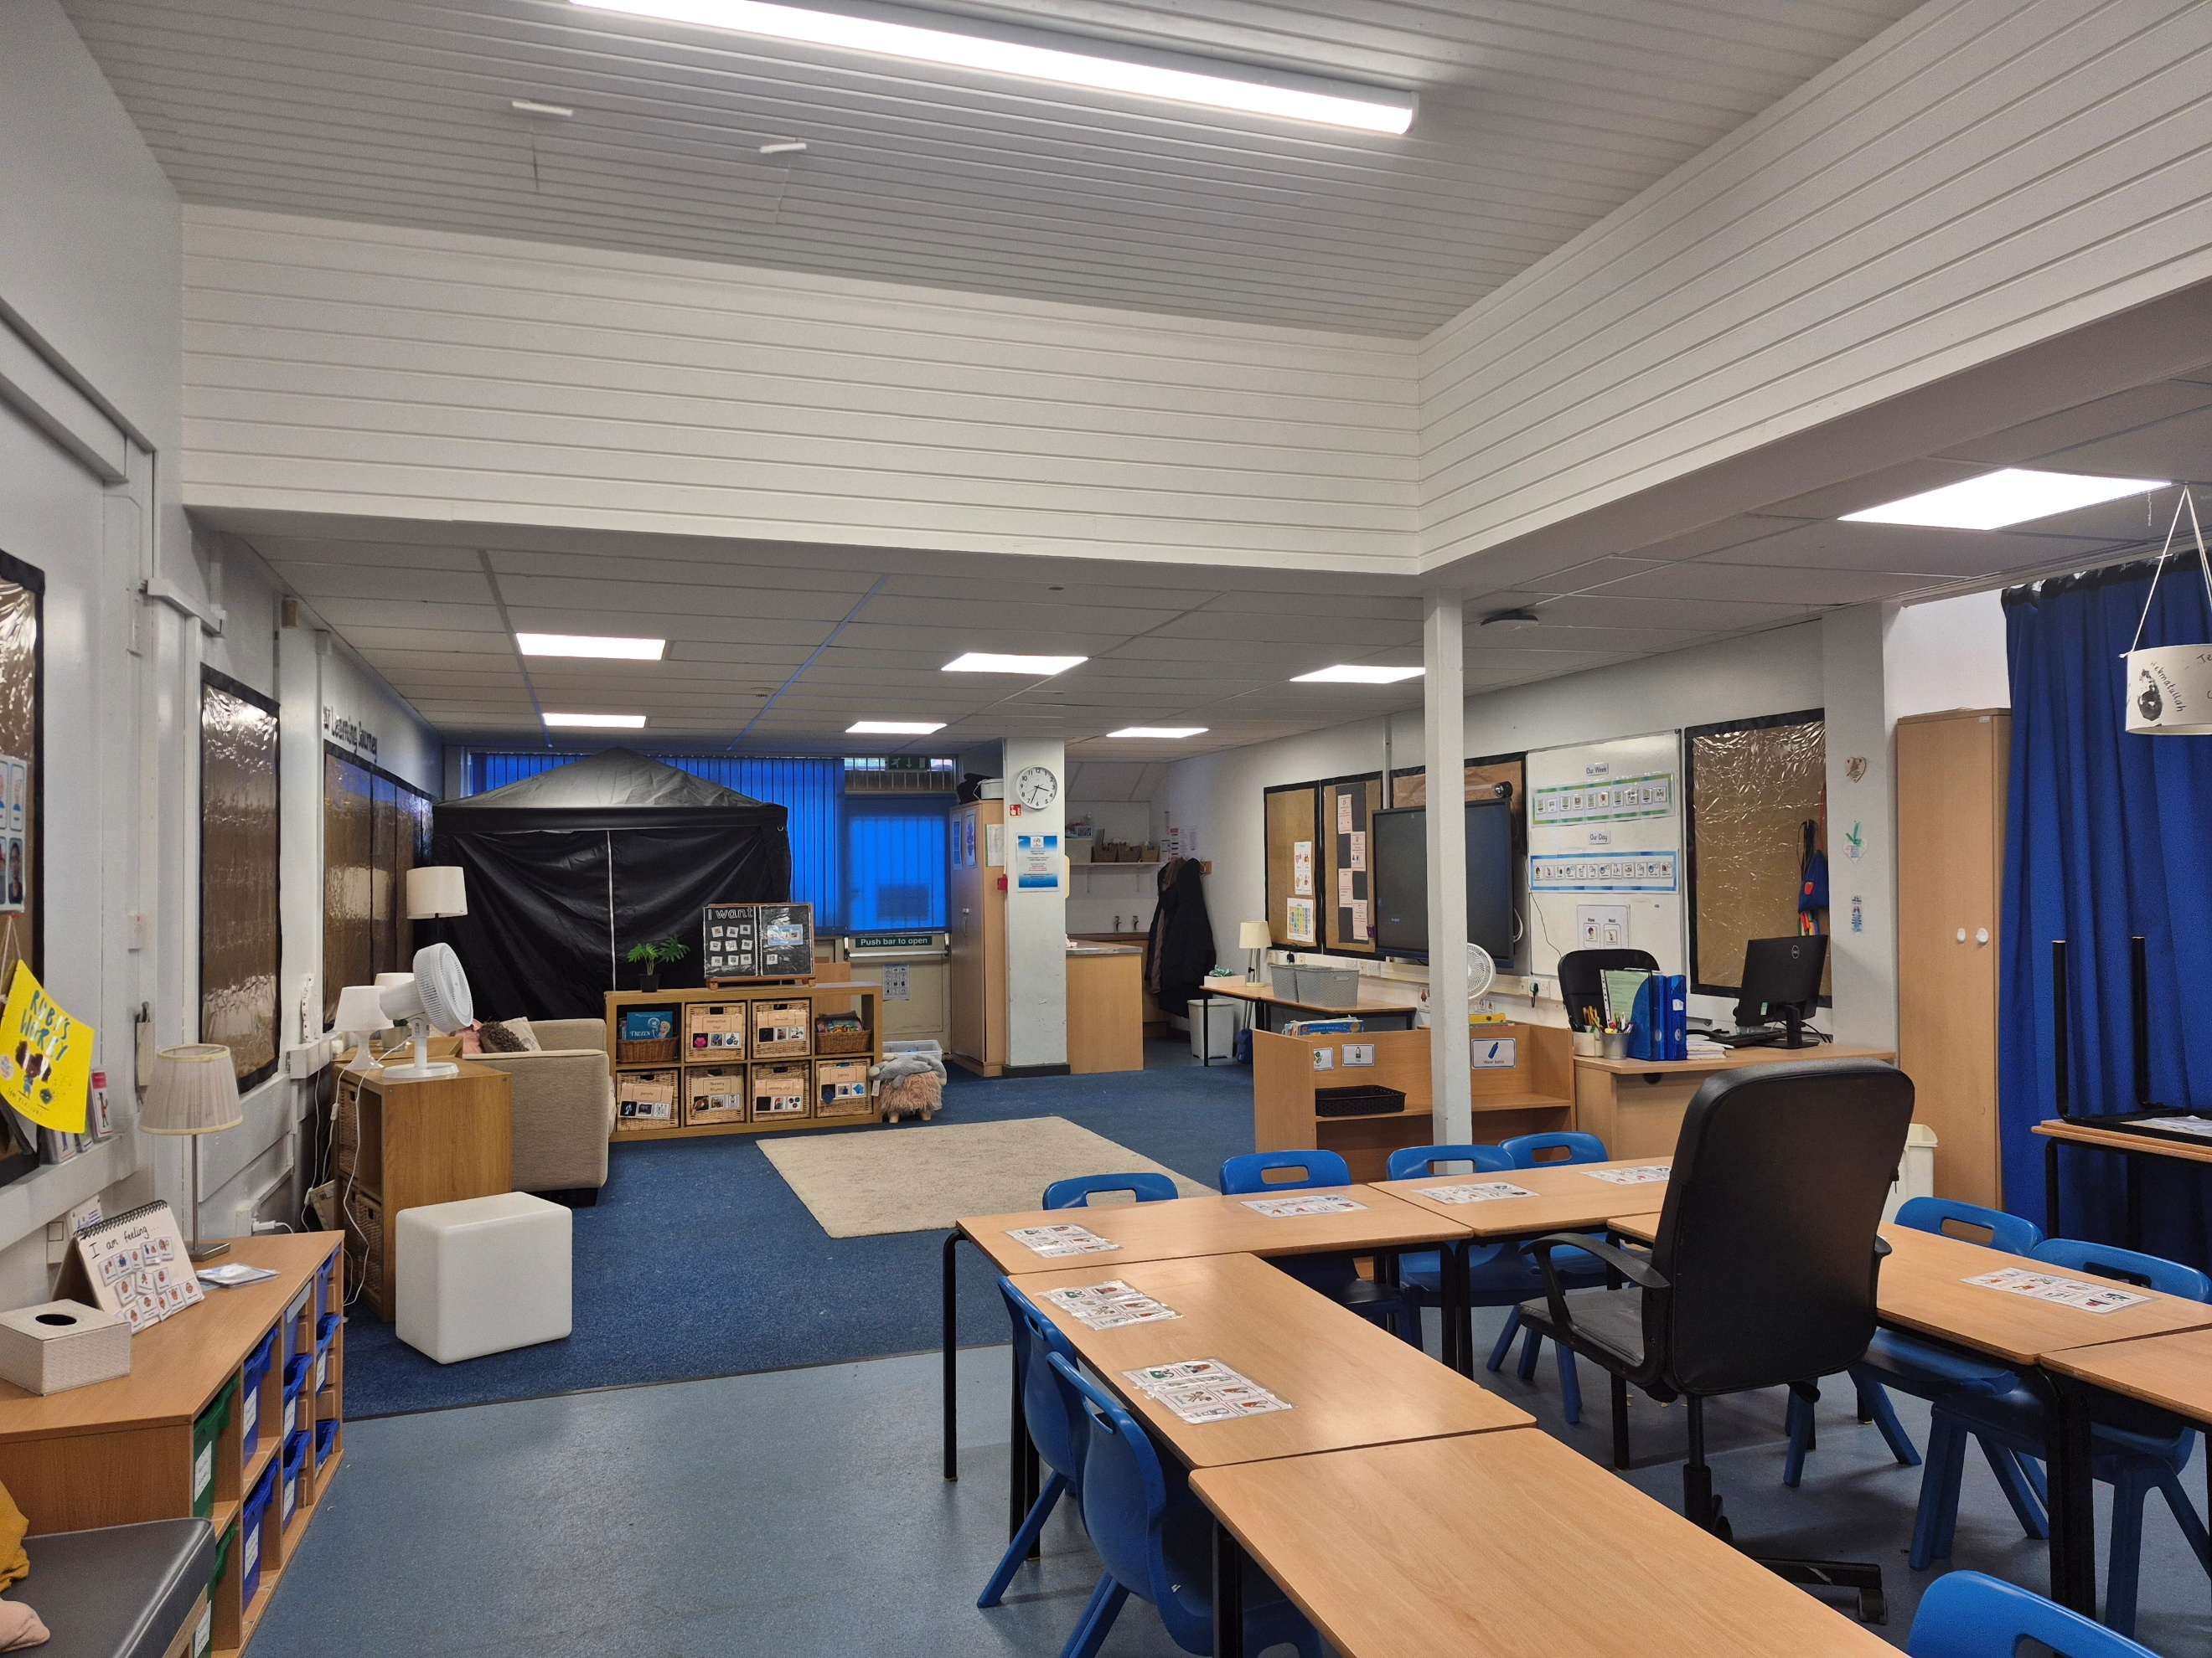

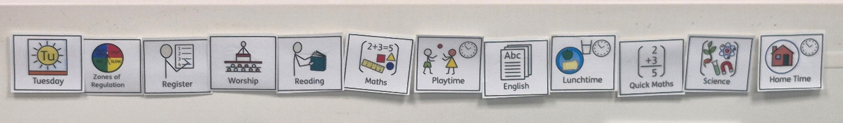
I will be able to find out what I am doing each day by looking at the visual timetable. The pictures will be the same and it will be clearly visible as I look towards the board in my classroom.
On a morning, I will wait with my adult in the playground outside our classroom.
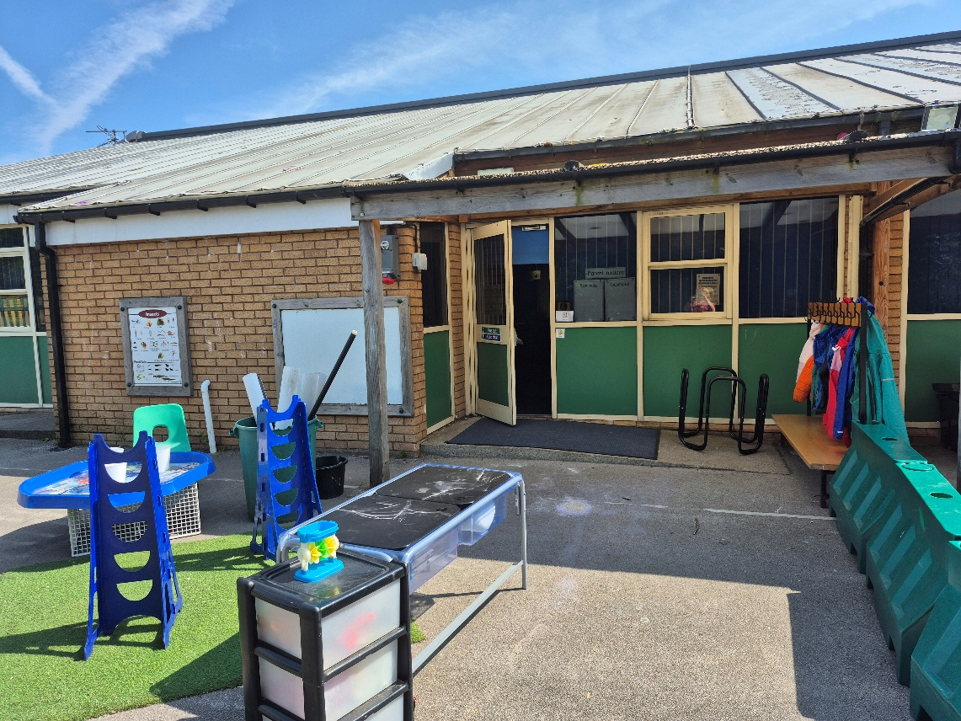

When my teacher comes to collect us, I will enter through our classroom door.
This will also be where I leave for break time and at the end of the day.

Things that will be the same.

I will have the same class teacher, Miss Wilkinson

I will still need to bring my water bottle every day.

I will still get Dojos.


We will do lots of different lessons.

We will still start our day at 8.30am and finish at 3pm.

Things that will be different.


I will have some new teaching assistants to support me.

Everyone feels nervous and maybe excited when they are starting something new.

It is ok to ask questions.
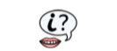
It is ok to not know what to do all the time.
Adults and friends will help you. You can ask them for help or ask them a question if you are unsure about something.
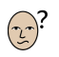
You will soon settle in and enjoy the new things that you do.

Soon it will seem like an ‘old’ classroom, not a new one!!
Well done!
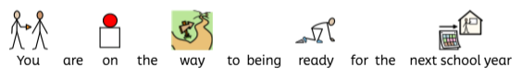
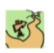
You are on the way to being ready for the next school year.

Clayton St John
'Be Ready Values'

•Be Kind and Friendly
•Be Safe and Wise
•Be Truthful and Forgiving
•Have Courage and Respect

“Give thanks the Lord, for he is good;
His love endures forever.”
1 Chronicles 16-34

“Growing Together in God’s Love”


