Multi-sensory activities to support the learning of spellings
(will also support the learning of letters and numbers)
When carrying out these activities make sure the pupil is saying the letters and then the word as they write them .
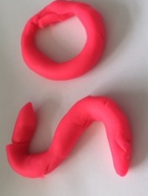  Play Dough Words - use play dough to form letters to spell out a word.  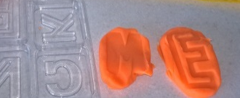 | 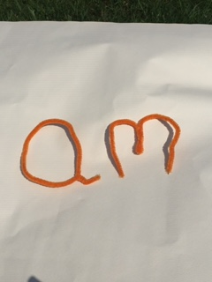  Pipe Cleaner Words - use pipe cleaners - bend and form to make letters and words. | Wool Words - supply some wool and scissors and let the child snip and create letters to spell out the words. | Letter Beads - use alphabet letter beads and pipe cleaners or string to thread and make words  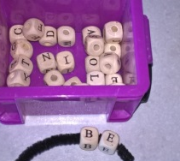
Stamp It! - use alphabet stamps and ink pads to stamp out words or let child use fingerprints to write words if you don't have letter stamps.  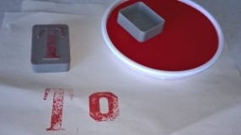 | 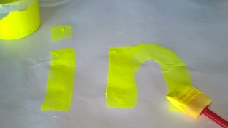  Paint It! - use a paintbrush and paint to spell words. | 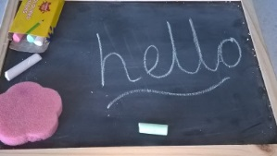  Chalk – write words with chalk an a chalkboard, on black sugar paper or outside on the playground. | Water writing – an alternative to writing words on the chalkboard. Use chalk to cover the chalkboard and have your child use a paintbrush (or their finger) dipped in water to write their words in the chalk.
Type It! - ask children to type their spelling words on the computer/ipad/lap top/phone. | Rainbow Words - spell words using different coloured felt tip pens or crayons for each letter.  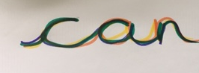 | 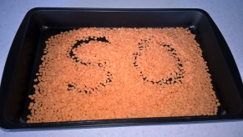  Sand/rice/lentils/glitter Tray – write the words with a finger in the tray saying the letters and then the words. | Trace - have fun and let the child trace their word on your back or palm or in the air. Have them focus on properly forming each letter so you can feel it being drawn.
Finger Paint - let them get messy and have some multi-sensory fun and finger paint their spelling words. | Shaving foam - Make a thin layer of shaving foam on a tray and ask you pupil to write the words with their finger. | 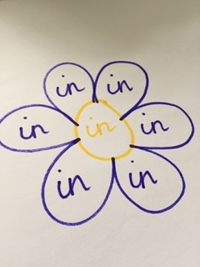  Picture Words – ask the child to draw a picture and then write the target word in each segment of the picture i.e. a flower or house. | Build a Word with building bricks-  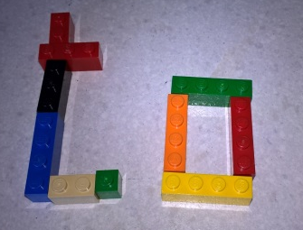
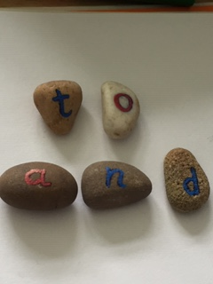  Alphabet Rocks - If you have a set of painted ABC rocks these can be a fun way to build and spell words. You could even make your own pebble letters. | Cotton Bud Writing - Use Cotton Buds and paint to dot letters to spell the word or write the word using the cotton bud as a paint brush. | Alphabet Stickers - build words using alphabet stickers | Small/Medium/Large Words  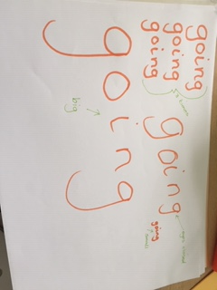  Get the pupil to write the word 3 times as quick as they can, as big as they can, as small as they can and with their eyes closed.
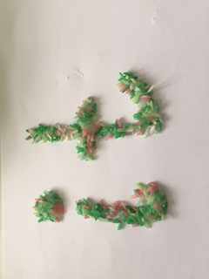  Glue & Glitter/rice/sand - Write out spelling words in glue and sprinkle some glitter on top. Glitter makes everything fun, doesn't it? | Wikki Stix – bend the wikkisticks to make your spelling words  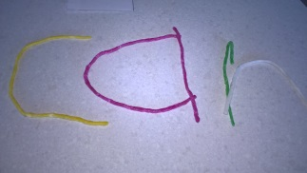 | 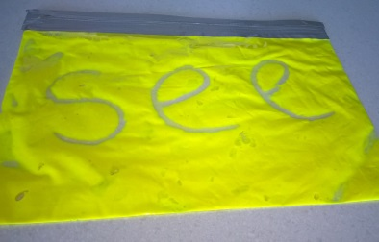  Paint Bags - Pour paint into a ziplock freezer bag and seal. Secure with some tape. Use fingertips to write words on bag. To erase, simply squish bag and you are ready for the next word. | Magic Painting Spelling Words - on a white piece of paper let your child write out the spelling words using a white crayon or candle. Once all words have been written use watercolour paints to make hidden words appear.
Scrabble Spelling - use scrabble tiles to build words.  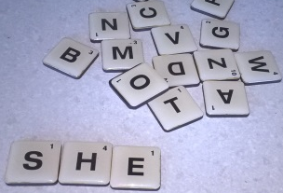 | 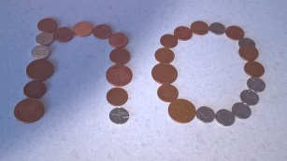  Coin / buttons / counters Spelling - use coins/buttons to make letters and spell out words.  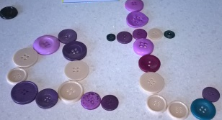 | Print Words - Use newspaper or magazine print to cut out fun letters. Have child make words using the clipped letters. | 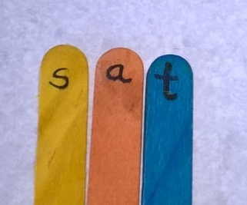  Stick Letters - use lollypop sticks, cotton buds or crayons to build letters and make spelling words.
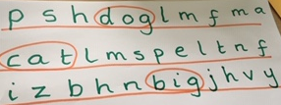  Tracking – make a simple sheet with a target word hidden amongst other letters in a line – can the child find the word? | 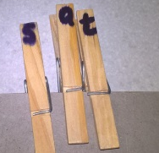  Peg Words - Write letters on clothes pegs and ask the pupil to peg letters to make words on the edge of a box or a washing line if available. | Cereal Words - using cereal like Cheerios or Rice Crispies make letters to form the target spelling words. | Bounce a Ball - bounce a ball as you spell words - 1 bounce per letter  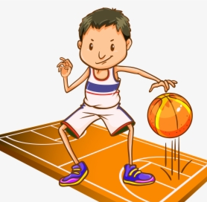
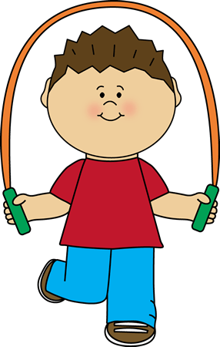  Skipping Rope -while orally spelling the words. |   Hula Hoop and spell words out loud. | 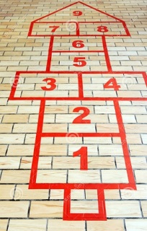  Hopscotch Spelling - Write letters outside in chalk or play indoors with large letter cards on floor. Hop from letter to letter to spell words. | Make tactile letters for the pupil to use to make words-  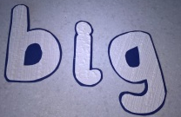  Textured wallpaper  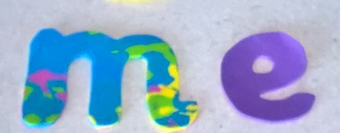  foam
Balloon Bop – challenge the pupil to keep a balloon up in the air while spelling a word.  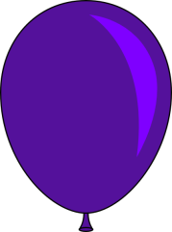 | Hop & Spell – can the pupil spell a word as they hop on one foot?  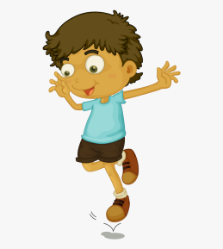 | Scavenger hunt 1 –  Hide the letters around a room – how quickly can the pupil find the letters to make a word you say? | 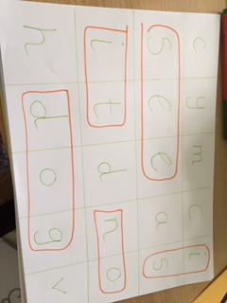  Wordsearch –make a simple wordsearch containing your child’s spelling words – can they find them?
Mystery Letters - write words with missing letters. Child must figure out which mystery letters are missing in order to complete words . | Word building - use magnet letters or letter tiles for each word, mix them up and ask the child to put the letters in the correct order to spell words.  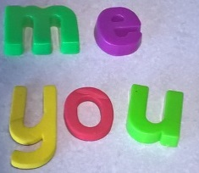 | Smelly words-  Use scented felt pens to write the words  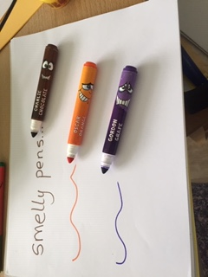 | Magnetic board spelling  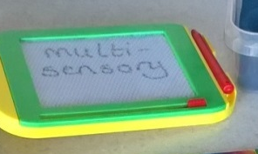  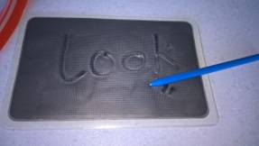
Water fun!Using a squirty bottle in the playground ask the child to squirt the shape of the letters to make the target word.  OR  Give the child a paintbrush and a bucket of water – can they ‘paint’ the words in the playground? |  | Scavenger Hunt 2 - Write words onto paper and cut apart the letters. Put letters in plastic tubs (yoghurt pots) plastic eggs or other such container and hide around the room. Have child find the words you've hidden and put words together correctly like a word puzzle.

