


Summer is here!
Welcome back Summer 1 term. Please find below support and resources offered in Bradford.
SEND Summer 1 Newsletter
sendco@claytonce.bdat-academies.org
01274 815862

Celebrating Neurodiversity week.

Last half term we celebrated Neurodiversity week. Our children made posters which are displayed in school. Please visit the school
website using the
QR code to see the
display.

Resources and support


Dyslexia Scotland provide fantastic resources and information leaflets to support your child with dyslexia.
---------------------------------------------
AWARE Autism Acceptance event, Tuesday 16 April 10am - 2pm.

Use the QR Code to book
your free place.
---------------------------------------------

Specialist Inclusion free family fun days! 28 May, 29 July, 7 September, 28 October
SEND Short Breaks assessment and Specialist Inclusion team run the fun days completely free and offer you a day out as a family, engaging in activities together at Nell Bank Centre – Ilkley.
Contact Halima, email: Halima.kara2@bradford.gov.uk and give your child's name, their DOB and diagnosis, your phone number and number of adult and child tickets you would like.


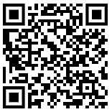

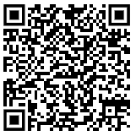
SEND website
Please visit the
school website to
find resources
and policies.

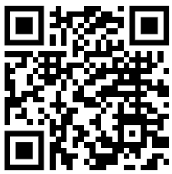

Dates to remember….

- Autism acceptance week beginning the 1st April.
- World Asthma Day – Tuesday 7th May.
- World voice day – Tuesday 16th April.

Summer is here!
Welcome back Summer 1 term. Please find below support and resources offered in Bradford.
SEND Summer 1 Newsletter
sendco@claytonce.bdat-academies.org
01274 815862

Celebrating Neurodiversity week.

Last half term we celebrated Neurodiversity week. Our children made posters which are displayed in school. Please visit the school
website using the
QR code to see the
display.

Resources and support

Dyslexia Scotland provide fantastic resources and information leaflets to support your child with dyslexia.
---------------------------------------------
AWARE Autism Acceptance event, Tuesday 16 April 10am - 2pm.

Use the QR Code to book
your free place.
---------------------------------------------

Specialist Inclusion free family fun days! 28 May, 29 July, 7 September, 28 October
SEND Short Breaks assessment and Specialist Inclusion team run the fun days completely free and offer you a day out as a family, engaging in activities together at Nell Bank Centre – Ilkley.
Contact Halima, email: Halima.kara2@bradford.gov.uk and give your child's name, their DOB and diagnosis, your phone number and number of adult and child tickets you would like.

SEND website
Please visit the
school website to
find resources
and policies.

Dates to remember….

- Autism acceptance week beginning the 1st April.
- World Asthma Day – Tuesday 7th May.
- World voice day – Tuesday 16th April.

