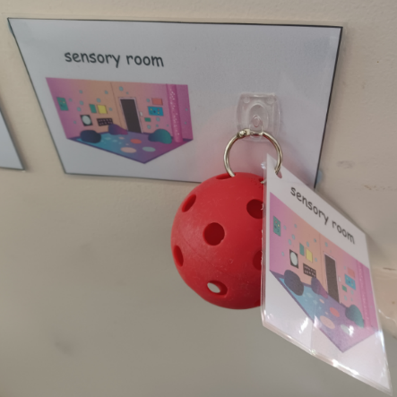
How to use objects of reference.

Why?
- An ‘object of reference’ is an object that symbolises an activity or routine and helps them to understand what’s coming next.
- They can support children in developing language, communicating requests and making their needs known.
- Objects can help reduce anxieties around the unknown.

You will need:
- A selection of objects that can be used. These can be:
  - a real object, for example a plate to represent meal times
  - part of a real object, a small piece of carpet to represent carpet time
  - miniature objects, for example a small toilet to represent going to the toilet
  - abstract objects, for example a string of beads to represent mum
- Examples of ‘objects of reference’:
  - eat – plate
  - drink – cup
  - change nappy – nappy
  - go to the toilet – toilet roll / toy toilet
  - go outside – stick
  - go inside – an indoor toy that interests them
  - sit on the carpet – piece of carpet
  - home time – key

How?
Show the child a familiar object that represents an activity before the activity begins.
- Ensure all staff use the same objects.
- Select a small number of regularly repeated activities and associated objects to begin with, for example, a cup for snack.
Where appropriate use objects in the home to introduce activities.

Things to note:
- Objects of reference need to be used consistently and by all staff working with the child for them to be effective.
- Children who have appear to have some spoken language will still benefit from objects of reference to help them make sense of routine and to support in functional communication.

Reference / Evidence base – informed by:
Massey, G., & Wheeler, J. (2000). Acquisition and generalization of activity schedules and their effects on task engagement in a young child with autism in an inclusive preschool classroom. Education and Training in Mental Retardation and Developmental Disabilities, 35, 326-335

