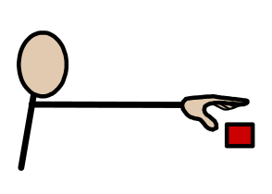
How to use sabotage to encourage communication.

Why?
- This is to support a child to make a request.
- Sabotage can be used to encourage communication. The practitioner deliberately withholds objects to prompt the child to request interaction either verbally or through their actions.

You will need:
- To understand what motivates the child.
- Build ‘sabotage’ into the session / school day.

How?
- Put motivating objects out of reach but within sight e.g. on a high shelf. | 
- Put motivating objects in transparent jars or wallets that the child is unable to open. | 
- Introduce toys which the child needs an adult to help them with e.g. bubbles, wind-up toys, toys with switches. | 
- Provide part of an activity e.g. a jigsaw with missing parts, one shoe, a yoghurt with no spoon. | 
- Give the child an unwanted item to encourage them protest e.g. snack that they do not like. | 
- Pause part way through a favourite rhyme or activity. | 

Things to note:
- Sabotage should remain fun – if the child is becoming frustrated then support them to achieve their goal.
- A request may be a glance, a tap or a noise – watch the child carefully so that you can acknowledge the child’s request.

Reference / Evidence base – informed by:

A handout from Airedale NHS Trust.

