Visual Picture Cards for non-verbal pupils or those with ASD.
Some individuals with possible traits or a diagnosis of Autism Spectrum Disorder may have difficulty in understanding and expressing language and others may have difficulties in change in routine or transitioning between different activities.
Visual cues can be useful in facilitating and supporting any child’s understanding, but particularly helpful for those with ASD or those that are not attempting to communicate with words.
Children with ASD may have difficulties with picking up and understanding social cues or prompts in the child’s context / environment.
Visuals help to understand instructions, express themselves, anticipate what is coming next as well as, motivate them through activities they find challenging.
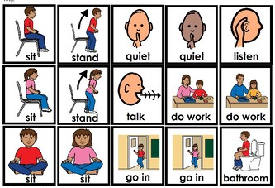
When communicating with a child that are not able to use their words and possibly show traits of ASD, it is most useful to remember that instructions are best being brief and to the point as too much information can increase the child’s anxiety – visuals can help support this by showing them what you need.
These are just some of the ways visuals can be used to support a child with autism spectrum disorder:

1. Now and Next board
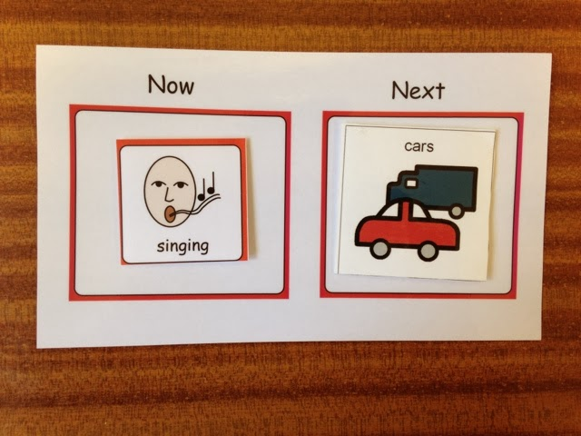
This is a useful visual to show the child what they need to do ‘now’ and ‘next’. The board has two columns in which you can velcro images that resemble activities. Different people may use different symbols or objects depending on what the child’s understanding. Once the child has finished an activity it can be removed from the board. This board can be used as a ‘first, next and last board’ if the child is expected to do three activities.
This can be particularly useful if the child does not want to do the first activity, meaning they will be able to see a reward or motivator for after they have completed the activity. Or can be used effectively for children who struggle with the transition between activities, in the case of a now and next board they can anticipate what they are expected to do next and prepare themselves for this.

2. Visual timetable (KS2 or older children)
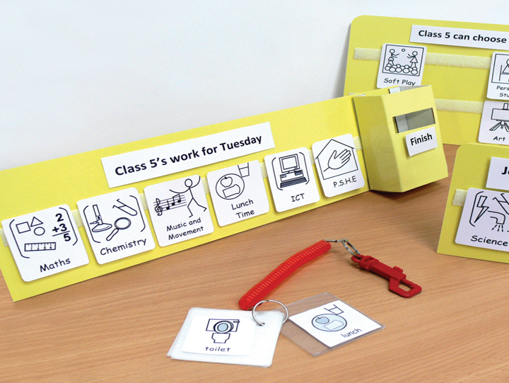
This is very similar to a now and next board but may resemble the whole day or the whole school day. This will be a strip where you can put all activities that the child may be doing in a day or a session so that they can anticipate and prepare for their day. Once activities are completed the child can remove the visual and make it into a fun activity by posting it away.

3. Objects of reference
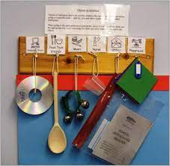
Objects of reference is where any real object can be used to represent spoken language. This can be the actual object or a smaller object (e.g. toy) to represent the meaning of the language. For example, if a child needs a drink they may point to their cup. This is useful for children who do not understand the representation of photographs or symbols and need the real object to express themselves or understand language used by others. People may use different objects to represent the same thing so it is important to get to know the child you are communicating with in order to truly understand their requests and comments.

4. Picture exchange communication system (PECS)
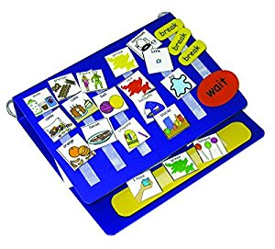
PECS is a form of augmentative and alternative communication (AAC) that uses symbols as a form of communication. It is specifically designed for children with autism and they are trained to exchange symbol cards for the item on the card. For example, the child may pass the card with bubbles on and then receive bubbles in return.
PECS works in different stages building up to the child having full independence in exchanging the pictures. The system works alongside spoken language and is a tool to reinforce the child’s understanding of different words, as the word is said each time the child exchanges a card. It also gives the child an opportunity to express themselves and get their needs and wants met.

5. Timer
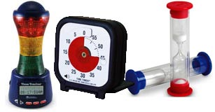
A timer is a simple and useful visual to support children with ASD. They are easy to use and provide many benefits. Timers can help children with transitioning between different activities, staying on task, tolerating un-preferred activities and monitoring reward time. It can also promote a child’s independence and time management as they can learn to use the timer automatically when they need to manage a task.
Sand timers can be used for a set specific time or electronic visual timers can be manipulated to time children during different activities that require different amounts of time.

Conclusion
As autism is a spectrum disorder, all children with the disorder are different. Therefore, all of the visual cues may not be appropriate to use for all children.
Each child with autism is individual and must be treated so, therefore getting to know the child and their needs is the first important step to consider which visuals would be most useful and supportive for them.
This is also not an exhaustive list and visuals can be used in many more useful ways.
If you need any resources, we have timers, now and next boards and other resources in the SEND room, and I can make cards on lanyards for you that are personal to your learning environment. Just see me when im in or drop me an email.

Caron Stone

