Relaxation Techniques
Calm Breathing for Younger Children:
Bubble Blowing is a fun way to teach younger child how to do calm breathing. Using a toy soap bubble container and wand (available at any toy store), encourage your child to practice blowing bubbles. The breathing required for blowing soap bubbles is the same as is used for calm breathing. Simply make sure your child waits a second or two before blowing another bubble. Then practice “blowing bubbles” without a bubble wand.
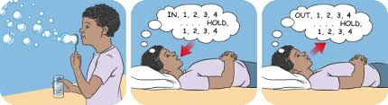

Breathing square.
Calm breathing is a technique that teaches your pupil to slow down his or her breathing when feeling stressed or anxious.
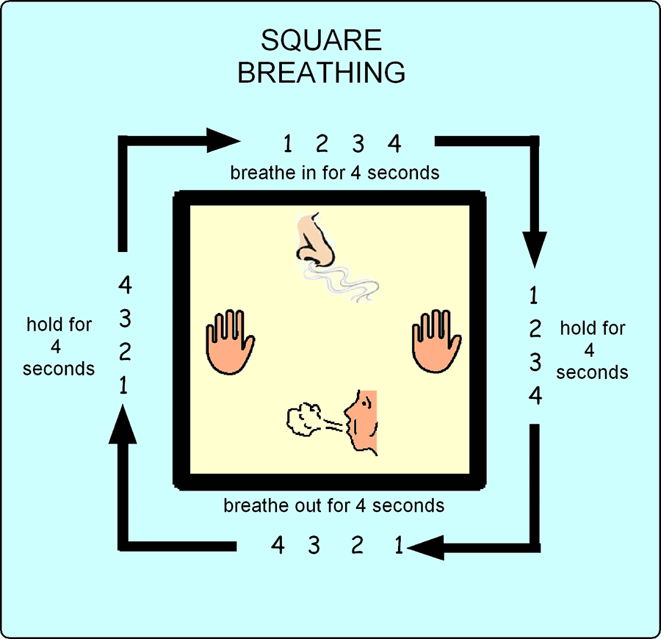
Take a slow breath in through the nose (for about 4 seconds) Hold your breath for 1 or 2 seconds Exhale slowly through the mouth (over about 4 seconds) Wait 2-3 seconds before taking another breath (5-7 seconds for teenagers) Repeat for at least 5 to 10 breaths

Five Things
- Pause for a moment.
- Look around and notice 5 objects you can see.
- Listen carefully and notice 5 sounds you can hear.
- Notice five things you can feel against the surface of your body.

Refocus whenever you feel disconnected.

Warm hands practice.
- Check in. Notice your body position and make adjustments so you are sitting comfortably. (Close your eyes and breathe) As you breathe out, allow your muscles to loosen a little.
- Tune in. Touch/ hold the warm object. What stands out as you make contact with the object? What are you seeing, hearing, smelling, tasting and feeling? What is the air like on your skin? What is the texture, weight and temperature of the warm object? Notice the fine detail of your different senses.
- Notice and return. Gently bring your focus (torch beam of attention) onto the experience of the warm object. Notice the physical sensations of touch, warmth and possibly movement. You may notice the rhythmic movements of your body as you breathe.

After a few minutes, gradually bring your attention to those things around you. Continue to breathe and slowly open your eyes.


Leaves on a Stream.
- Find a comfortable position and close your eyes (or fix them on a spot)
- Imagine you are sitting by the side of a gentle flowing stream, and there are leaves flowing past on the surface of the stream. Imagine it however you like.
- Now for the next few minutes, take every thought that pops into your head and place it on a leaf, and let it float on by. Do this regardless of whether the thoughts are positive or negative, pleasurable or painful. Place them on a leaf and let them float on by.
- If your thoughts stop, just watch the stream. Sooner or later the thoughts will start up again.
- Allow the stream to flow at its own rate. You are allowing the leaves to come and go in their own good time.
- Continue to watch the stream until you begin to notice those things around you. Continue to breathe and slowly open your eyes.

Picture your favourite place.
- Close your eyes. Picture a favourite place, like the beach. Think about how it looks, sounds, smells, and feels. Focus on details like the sound of waves crashing, the feeling of wet sand on your toes, and the scent of salty ocean air.

