Starter- plurals means more than one.
Can you add s or es to the words below?
For example bus- buses
Church
Dish
Pen
Dog
Fox
Box

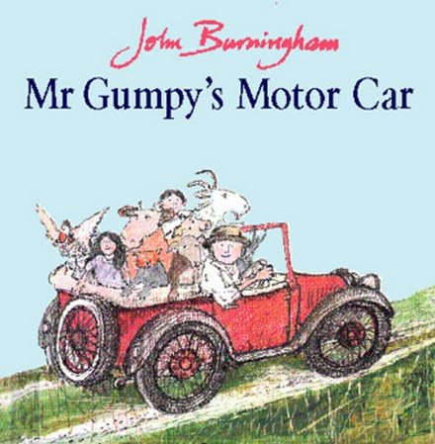

Write sentences to describe Mr Gumpy’s motor car. Remember to use conjunctions.
For example. Mr Gumpy was cross because they animals wouldn’t help him.

