Wednesday 23rd June
End of unit assessment – Are all animals the same?
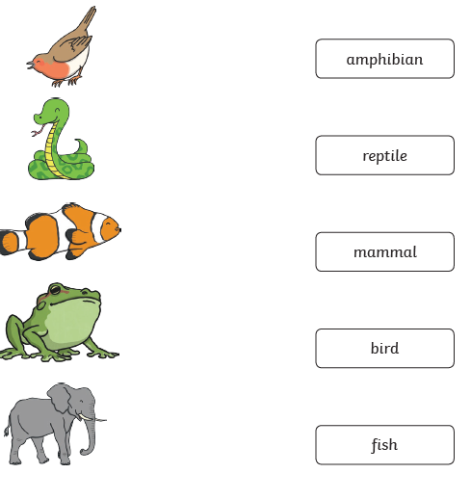

2. Write one fact about these animal groups.
Mammal ______________________________________________________________________________________________________________________
Fish
______________________________________________________________________________________________________________________

3. Give an example of each of these types of animals.
Bird ___________________________________
Reptile _________________________________
Mammal ________________________________
Amphibian _______________________________

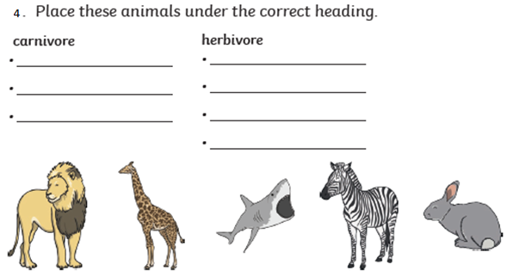
Lion Giraffe Shark Zebra Rabbit

5. If an animal eats both meat and plants, what are they called?
_______________________________________________
6. What is a human who doesn’t eat meat?
________________________________________________
7. Are all animals the same? Write sentences to explain your answer.
____________________________________________________________________________________________________________________________________________________________________________________________________________________________________________________________________

