Starter:
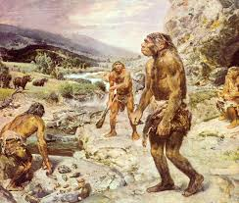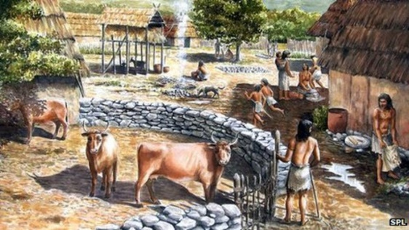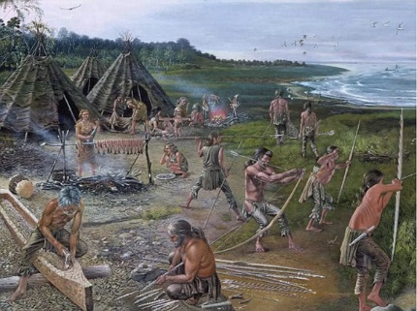
Palaeolithic Mesolithic Neolithic
Describe the difference between each era of the Stone Age.

Starter:
Palaeolithic Mesolithic Neolithic
Describe the difference between each era of the Stone Age.

Starter:
Palaeolithic Mesolithic Neolithic
Describe the difference between each era of the Stone Age.

