How is the nature of God revealed in the architecture of York Minster?
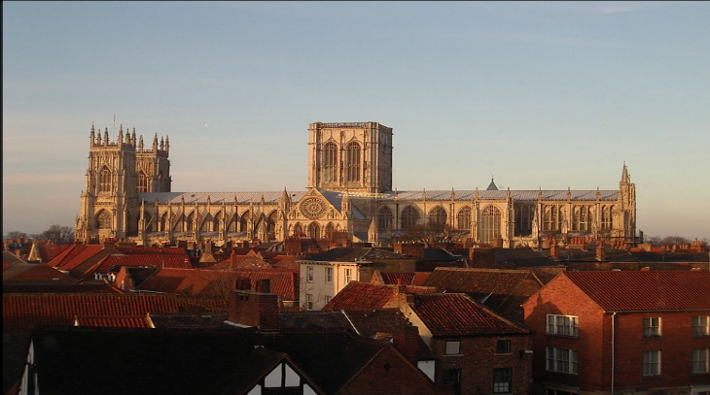
It took 250 years to build York Minster – 1220 to 1472! Imagine arriving at York Minster for the first time in the 13th century. You would never have seen a large building before. Few buildings were made of stone. Most would be made of wood with thatched roofs and no glass in the windows.
York Minster is HUGE! You are meant to feel awe and wonder at the house of God as you approach.

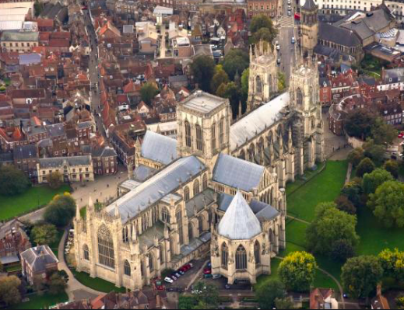
Christian churches are built in the shape of the cross. They face west to east.
When you walked in through the doors, the sun would be shining through the stained glass. The vaulted ceilings would reach up to the heavens. You would feel you had arrived in Paradise.

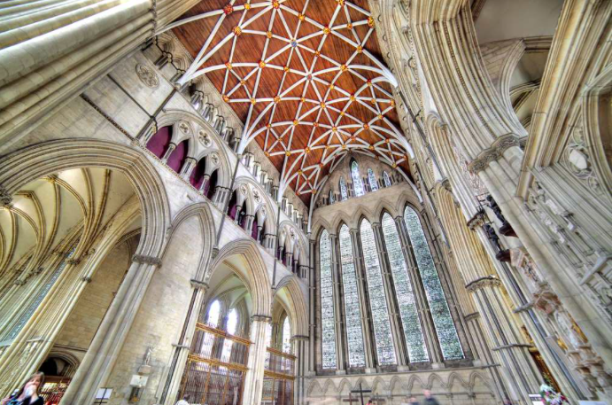
The rood screen
Rood is an Old English word meaning cross or crucifix.
In the Tabernacle and the Temple, the Holy of Holies was separated from the ordinary people.
The rood screen separates the high altar from the ordinary people.
Passing through the rood screen brings you nearer to presence of God.
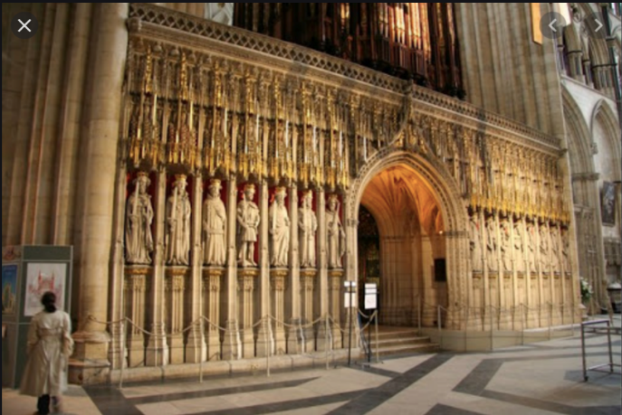
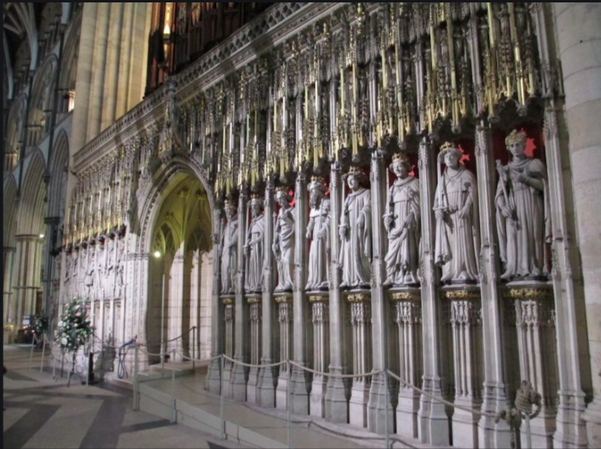
The High Altar is set at the east end of the church. In the Temple and the Tabernacle, priests made sacrifices on the altar. In a Christian Church, the priest blesses the bread and wine on the altar – remembering Jesus as a sacrifice for sin.
The high altar makes people feel the holiness of God.



