Refugee Week
What is Refugee Week?
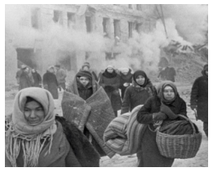
Refugee Week is a UK programme of arts, cultural and educational events and activities that celebrate the contribution of refugees to the UK. It aims to help people understand why others have to become refugees. Refugee Week usually takes place in June. Anyone can be involved by either organising, attending or taking part in activities.
What does being a refugee mean?
A refugee is someone who has had to leave their own country because they are being treated badly or are in fear of being treated badly. Sometimes, people can be afraid of being hurt, or even killed, because of their religious beliefs or because of where they are from. People are often forced to become a refugee because of war, bad leadership in a country or natural disasters.
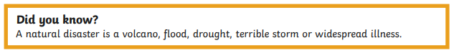
When did Refugee Week begin?
Refugee Week began in 1998 because there was a lot of incorrect information about why refugees came to the UK. Many newspapers reported that refugees were here for money and ‘free housing’, and there were a lot of bad feelings towards refugees.
The organisers of Refugee Week say:
“Our ultimate aim is to create better understanding between different communities and to encourage successful integration, enabling refugees to live in safety and continue making a valuable contribution”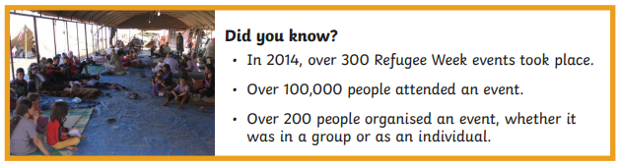
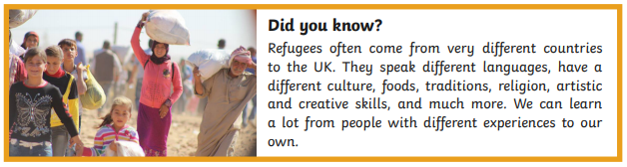
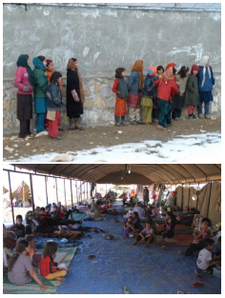
What happens during Refugee Week?
Refugee Week is an exciting time of arts festivals, exhibitions, films, theatre and dance performances, concerts, football tournaments and public talks. It is also important that children are involved, as their opinion matters and they will make decisions about worldwide issues like refugees in the future. Schools are invited to have creative and educational experiences to gain more understanding of refugees in the world.


