What was the House of Wisdom?
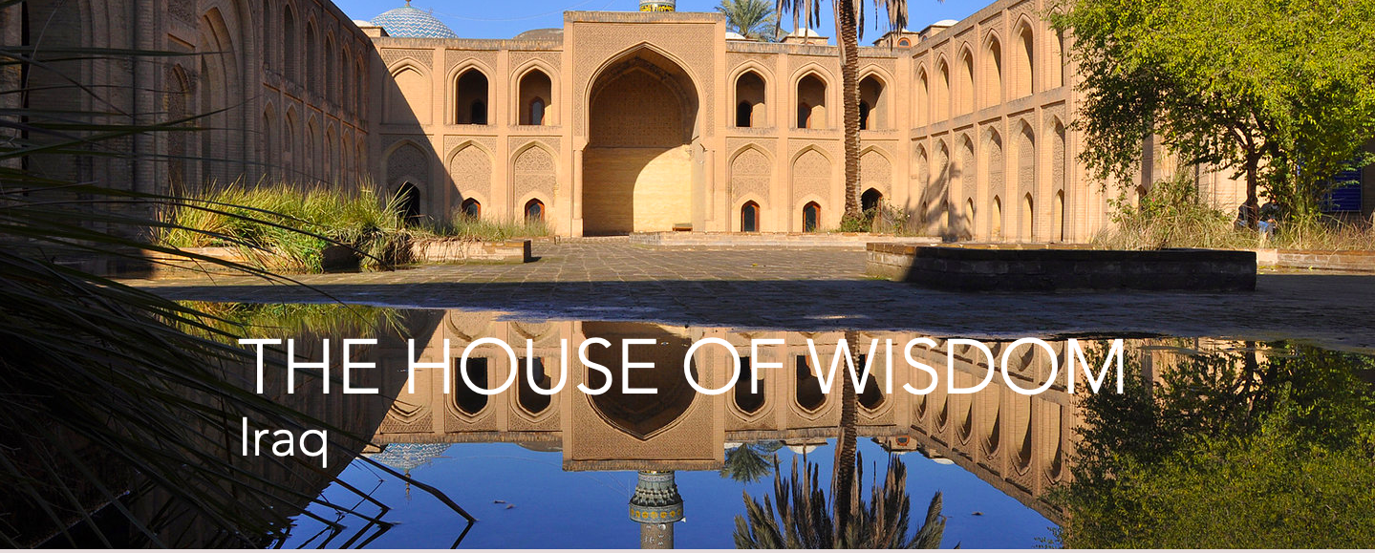
Many great minds over the ages have discovered and invented ideas and knowledge. None of this can outlive the life of the person without being recorded or written down in some way. Only the creation of a library storing many manuscripts and books containing these ideas and theories could retain all that knowledge.
The House of Wisdom started out as a great library containing over 400,000 books. It was built by caliph Harun al-Rashid. A caliph is a ruler of an Islamic state. A caliph is believed to be the successor of the messenger of God. Caliph al-Rashid intended the library to house the collected books and manuscripts of his father and grandfather. These men searched all over the world for knowledge. They bought books and manuscripts in order to find out what great minds had discovered over the centuries.
His son Caliph al-Ma’mum expanded the library into an academy after his father’s death. The library was extended with study centres and an observatory becoming part of it. The library became an academy known as the House of Wisdom.
The House of wisdom was largely responsible for the preservation of ancient Greek and Roman works. The works of Plato, Aristotle, Ptolemy and Euclid were housed there. The House of Wisdom also attracted scholars from all over Europe and the Middle East - Persians and Christians are like. At this time it was the intellectual centre of the world. It was a place for scholars to meet and discuss with others of like mind, a place for research and experimentation. One of those minds was mathematician al-Khwarizmi the founder of algebra and algorithm. Another was the famous scientist, medical scholar and philosopher, Ibn Sina, known now as Avicenna.
Not only could you go to the House of Wisdom to find out new ideas and learn but also you could become rich. Scholars were encouraged to add their works to the House of Wisdom’s collection. Those who did rewarded in gold - equivalent to the weight of the books.
Great things must come to an end however all great things must come to an end. This came in the year 1258 for the House of Wisdom. The Mongol invasion quickly destroyed Baghdad. The Mongols destroyed the library, houses and hospitals. The residents were all slaughtered as were the scholars of the house.
The Mongols threw all the books and manuscripts from the House of Wisdom into the Tigris River. It was said that the river ran black from ink and red from the blood of the people.
What would’ve happened if the Mongols had never come to Baghdad? Would we live in a world that was more technically advanced or would it be more the less the same? We will never know.

