The Basra Times
By: Mr Rajan 19th April 2021
editor@basratimes.com

Sinbad, the luckiest man alive?
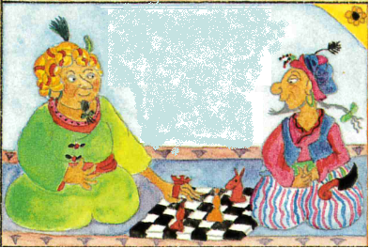 | precise), he defied death not one, not two but three times. Firstly, as soon as their ship approached Isle of Zughb, they were attacked by ape-like men and they seized the helm. There was every chance that those pirates could have killed them all but they left the ship crew along with Sinbad stranded on the isle and took their ship. Famished and exhausted, they sought a shelter to spend the night. Then, they found a huge, creepy, abandoned castle and little did they know that it was home to a colossal, cruel and fearsome giant. The giant roasted and ate the captain on first day and another merchant on the second day. Eventually, they built a raft and cautiously escaped but only Sinbad and two others managed to survive this ordeal. Thirdly and finally, when their raft arrived at another island, they were attacked by a great serpent who ate the other two survivors. Sinbad escaped death this time by building a strong, wooden box and hiding inside it every time the serpent was around.  We have learned that Sinbad the Sailor had similar yet unbelievable brushes with death during his other six voyages as well. However, it may be convenient to just say that he is ‘the luckiest man alive’ but it is not as simple. We asked our Mrs Rhodes (Chief Advisor to the Caliph of Basra) and she said “He is very lucky yes, but luck alone cannot help you survive every time. I think, Sinbad is also a very courageous and intelligent sailor. His tenacity to survive is unlike anyone else and more importantly, he carries the blessings of all the poor people he has helped in Baghdad”. Sinbad truly is a national hero and he inspires us to have the courage to follow our dreams and to remain considerate towards the needy and the less fortunate.  You can find details of all seven voyages of Sinbad along with pictures of his latest feast on our website www.basratimes.com and you can also follow us on Twitter and Instagram @basratimes.
In this picture, Sinbad the Sailor (right) with Caliph of Basra (left)
BASRA. A merchant from Baghdad has become a national hero! Today, Sinbad (more popularly known as Sinbad the Sailor) has become a household name for facilitating trade and friendship between Caliph of Basra and King Serendib. Wanting to learn more about this great ambassador of our country, we went to Baghdad. Astonishingly, he just might just be the luckiest man alive!

Even before becoming close to the Caliph, Sinbad the Sailor has been a celebrity for the people of Baghdad, for the tales of his death defying and larger than life voyages. Determined to find out more about him, we spoke to several people about him at the ports of Baghdad. A porter (whose name was also Sinbad) said, “Sinbad is a great man! He always helps the poor and provides food and money to the needy. He invited me inside his huge, heavenly home; offered me food and gold; and told his remarkable stories. May Allah give him long life!”

Sinbad the Porter generously shared details of Sinbad the Sailor’s voyages with us. Having heard all the incredible details, we were struck with disbelief. He told us that one on one of his voyages (third to be

Writing skills used: parentheses; direct speech; -ed and –ing sentence openers; expanded noun phrases; adverbs to add details

