Christian Eriksen: How did CPR and a defibrillator save his life?
Footballer Christian Eriksen collapsed in Denmark's opening Euro 2020 game against Finland last weekend. He was given life-saving treatment on the pitch and was taken to hospital where he's now recovering. Eriksen says he is "fine under the circumstances" and is getting a device called an ICD fitted to help his heart in the future. But the treatment Eriksen received on the pitch - called CPR and a machine called a defibrillator - almost certainly saved his life. Denmark played against Belgium last Thursday (17.06.21) and during the match both teams stopped play to make a tribute to Eriksen and the medical staff who helped him. Read our guide to find out more about the special treatment that helped save him.
What is CPR? 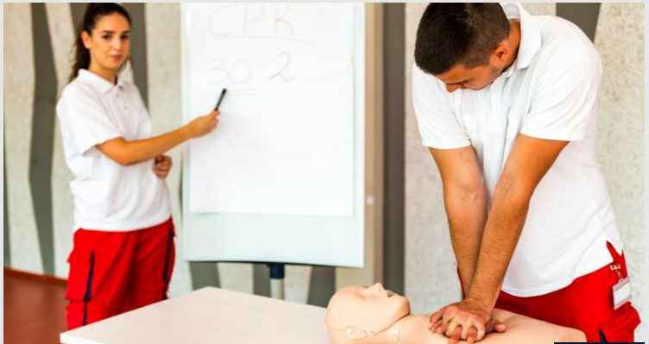
CPR stands for 'cardiopulmonary resuscitation' and is given to someone who is in cardiac arrest. A cardiac arrest is when the heart suddenly stops pumping blood around the body. When the heart stops pumping blood, it means the brain stops getting oxygen. This causes someone to fall unconscious and stop breathing.
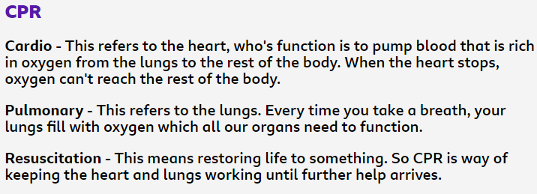
CPR is a life-saving technique that helps to pump blood around a person's body when their heart can't. It is only given if someone is unconscious and not breathing or not breathing normally.
To carry out CPR a trained person will press up and down on a person's chest.
In the past, CPR would also be given with a series of rescue breaths. However, current guidance advises not giving rescue breaths due to the risk of coronavirus.
Sudden cardiac arrest - like what happened to Christian Eriksen - is very rare in children.
What is a defibrillator?
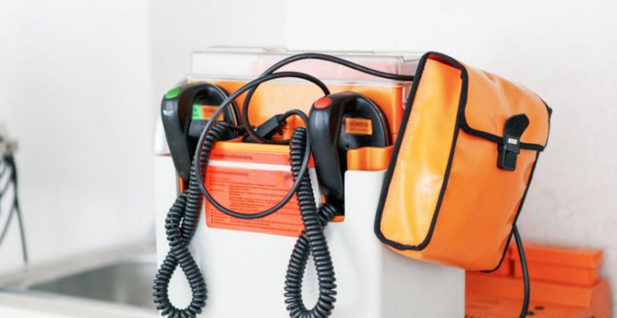
When a person has a cardiac arrest a defibrillator can be used to shock the heart back into a normal rhythm. A defibrillator is a small device that is simple and safe to use. It has two pads that attach to the person who needs it and will give clear instructions on what to do.
The British Heart Foundation describes a defibrillator as "a device that gives a high energy electric shock to the heart of someone who is in cardiac arrest.”
"This high energy shock is called defibrillation, and it's an essential part in trying to save the life of someone who's in cardiac arrest."
It will not give a shock unless it's appropriate.
Defibrillators are available to the public in busy locations like shopping centres, sports stadiums and train stations across the UK. These defibrillators are known as public access defibrillators (PADs) as anyone can use them. Christian Eriksen received one shock from a defibrillator that helped save him.

