Our Solar System
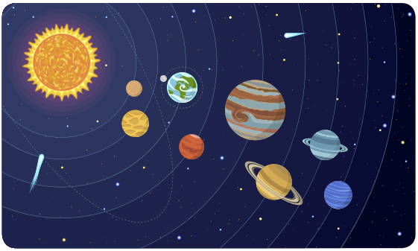
Every star has a Solar System. The Sun is the star of our Solar System. The Earth is one of a family of eight planets. All of these are orbiting round the Sun. Together with the Sun and the eight planets along with other celestial bodies make our Solar System. All eight planets are different in every respect. For example, in shape, size and conditions. The distances between the planets are enormous; much farther than the picture above. The planets in our Solar System are Mercury, Venus, Earth, Mars, Jupiter, Saturn, Uranus and Neptune. In addition to these eight planets are five smaller dwarf planets. As of August 24, 2006, Pluto was no longer considered a planet and is instead described as a Dwarf Planet. The Dwarf Planets in our Solar System are Ceres, Pluto, Haumea, Makemake and Eris.
Mercury
This is the smallest planet, roughly the size of our moon and is closest to the Sun. Its mass is not great enough to produce a strong gravitational field and for this reason it is unable to sustain atmosphere. The gases just simply drift into space. The side of Mercury facing the Sun can reach temperature high enough to melt lead (430ºC), while the dark side drops to -170ºC.
Venus
It is almost the same size as the Earth. It is an unpleasant planet. It has a rocky surface, covered by dense clouds of sulphuric acid and carbon dioxide. These clouds of gas entirely hide the surface of Venus. This traps the Sun's heat due to the ' Super Greenhouse Effect' and for this reason it surface temperature is higher than that of Mercury (approximately 500ºC). Without this atmosphere, Venus' temperature would be a lot lower. It reflects a lot of light, so Venus looks bright. It is also known as the 'Morning and the evening Star'.
Earth
If you view the Earth from space, it looks blue with swirls of clouds. Its surface is rocky, with mountains and canyons, which are covered with water and ice. It is the only planet with water, oxygen and living thing. Planet Earth has just the right conditions for life to exist, because it is at the right distance from the Sun. It has one moon. No doubt, other stars in the universe might have planets with the same life sustaining conditions.
Mars
It is called the red planet. It is dry cold desert of red rock, with massive mountains and canyons. It is most like Earth. It has a thin atmosphere of carbon dioxide (95%), nitrogen, oxygen, water vapour and noble gases and there is no life on it. It has 2 small moons. The dark patch is a giant volcano.
Jupiter
The largest of the planets and the coldest. It has no solid surface, it is a liquid giant. It is made up of mainly liquid hydrogen and helium, surrounded by these gases and clouds. The bands of colour, in Jupiter are produced by different regions in the atmosphere. The great red spot is thought to be an area where the atmosphere constantly swirls around a giant storm. This spot is 3 times the size of Earth. Jupiter is surrounded by 16 moons.
Saturn
A gas giant, very much like Jupiter. It is made mostly of hydrogen and helium. It has the most striking ring system of all the outer planets. The 18 rings are made from billions of tiny particles of rock and ice. They are held together in orbit by the pull of Saturn's gravity. It has 18 moons.
Uranus
Another gas giant, made up of hydrogen and helium. It is different from other planet, because it is lying on its side as it goes round the Sun. The spin axis of Uranus is tilted at 98°, so that at times it poles point towards the Sun, giving rise to extreme seasons. It has 15 moons and 11 rings.
Neptune
Appears in the sky as tiny blue-green speck, using even the most powerful telescope on Earth, because it is so far away from the Sun, where the light is one thousandth as strong as on Earth. Neptune is a ball of water and rock, consisting of atmosphere of hydrogen, helium and methane. The great dark spot is a storm, about the size of Earth.

Ceres
Between the orbits of Mars and Jupiter is a disc made up of asteroids and minor planets. The dwarf planet Ceres is the largest object in the asteroid belt and the only object in the belt to be rounded by its own gravity. Ceres is the largest dwarf planet and the only one closer to the sun than Neptune. It’s the 33rd largest known object in our solar system. When Ceres was first discovered in 1801, it was considered to be a planet, but was later classified as an asteroid in the 1850s.
Pluto
The smallest and the outer most of all the planets, discovered in 1930. It is of low density, composed of rock and ice, with frozen methane on its surface and thinly spread in the atmosphere. Pluto's elliptical orbit occasionally takes it within the orbit of Neptune. It has one moon.
Haumea
Haumea’s discovery was announced in 2004 and it was classified as a dwarf planet in 2008. Haumea is roughly the same size as Pluto and scientists believe it’s made up of rocks and ice. A day on Haumea lasts only four hours but it takes Haumea 285 Earth years to orbit the Sun. Haumea is the first known Kuiper Belt object to have rings.
Makemake
Makemake has an extremely low average temperature of about -243.2°C and has a surface covered with methane, ethane, and possibly nitrogen ices. Makemake was discovered on 31st March 2005 and was classified as a dwarf planet in July 2008. Its unofficial codename is ‘Easterbunny’, as it was discovered just a few days after Easter. It takes Makemake 305 years to orbit the sun but its day is a similar length to ours, lasting 22.5 hours. Light from the sun takes six hours and 20 minutes to reach Makemake. Makemake appears to be reddish-brown in colour.
Eris
Eris is one of the larger known dwarf planets in our solar system but, like Pluto, it is smaller than our moon. Eris is extremely cold and its temperature ranges from -217°C to -243°C. When Eris’ orbit takes it far away from the sun, its atmosphere freezes and falls to the ground. When it gets closer, the atmosphere thaws.

