The Life Cycle of an Amphibian (Frog)
Like beautiful butterflies, frogs and toads undergo an astonishing transformation – which is called ‘metamorphosis‘ – as they grow up. From jelly-like eggs laid in water, they grow into wriggling tadpoles, and finally grow legs suitable for land! But how does this mesmerising metamorphosis work? Let’s have a look at each stage of the frog life cycle in turn, to find out…

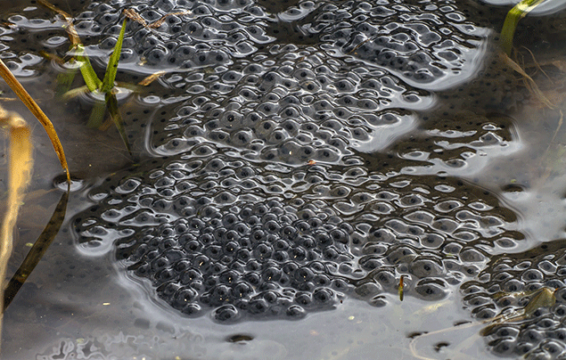
Stage 1: Extraordinary eggs
It all starts with adult frogs laying hundreds of tiny eggs, which clump together in groups known as frogspawn. This happens in early spring, when the weather is just starting to get warmer. Spotting frogspawn is often thought of as being a key sign of spring! You can hunt for frogspawn in shallow, still water – a garden pond, for example! As the eggs are defenceless, they’re usually laid among vegetation and just below the surface of the water, to give them some protection.
If you’re lucky enough to spot some of these strange eggs, pay attention to their shape. Frogs lay ‘frogspawn’, which looks like a round cluster of eggs, while toads lay ‘toadspawn’, which comes in long ribbons. In the frogspawn, the baby frogs start out as tiny black dots surrounded by a jelly-like substance. Over time, they become comma-shaped, as their tails begin to develop – amazing!

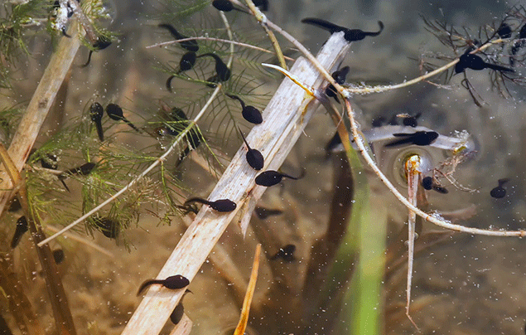
Stage 2: Teeny tadpoles!
After spending 1-3 weeks eating the yolk of their egg, the baby frog hatches into the big, wide world. Now, the baby frogs are known as tadpoles. They have gills, a mouth, and a long tail, which they need for swimming
For the first week or two after hatching, tadpoles won’t move around very much, as they’re still absorbing some nutrition from the yolk of their egg.

However, once the yolk is all gone, the tadpoles are big and strong enough to venture out into their watery world! Unlike adult frogs, tadpoles can’t go on land – so they feed on plant material filtered from the water, and tear off tiny chunks of nearby vegetation. The legless, water-bound tadpoles slowly metamorphose into frogs over the next 14 weeks.
First, they grow back legs, then front legs too! Soon after, their body starts to change shape, and they’re able to start eating insects. Next, the tadpoles’ tails shrink away, and skin grows over their gills, as they develop lungs and eardrums! These are important steps, as they prepare the tadpole for life on land. Once their gills and tails are gone forever, tadpoles undergo one last 24-hour push, where the metamorphosis completes. Once this stage is finished, the baby frogs emerge from the water as tiny adults!

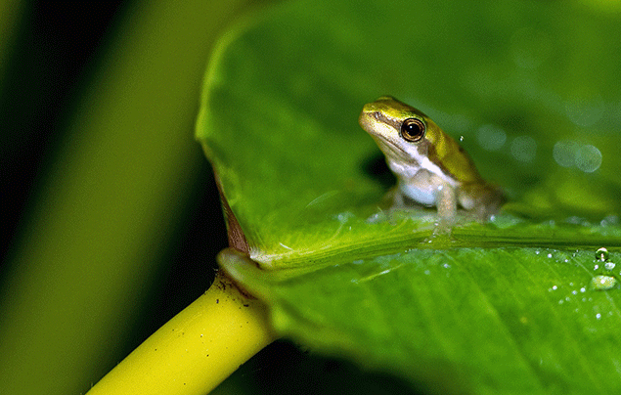
Stage 3: Fully-grown frog!
And there you have it – the frogs are all grown up, and ready to head out into the big wide world!
As adults, frogs and toads are much less reliant on water. So long as they stick to the shade and don’t dry out, they can live on land – but they often return to ponds and lakes for a splash!
Before too long, the females will look for water to lay her own eggs. Once that’s happened, the life cycle is complete – what a frog-tastic life they lead!

