Fairtrade – What’s it all about?

Fairtrade is all about making things fairer for the people in developing countries who grow and harvest the food we eat. It is a global movement which is represented in the UK by the Fairtrade Foundation, whose logo you’ll likely have seen on many supermarket products. When you spot it, it means that the ingredients in the product have been sourced in a way that does not damage the environment, and that all the workers who helped produce the product have been paid fairly and enjoy decent working conditions. As well as paying fair prices, companies that use the Fairtrade mark also contribute towards making life better for the people they are trading with, by giving money for things like schools, water pumps and health clinics – without them having to work their fingers to the bone just to afford bare essentials.

Fairtrade is a response to traditional trading arrangements which can be very unfair. Often, shops and businesses in first world countries such as the UK can take advantage of workers in developing countries who have very little money to put into their community or business, but badly need to sell their product. This means that farmers and other labourers have no say in their own futures, and are often taken advantage of. Long working days, back-breaking labour and poor pay are just a few of the ways workers can be exploited.
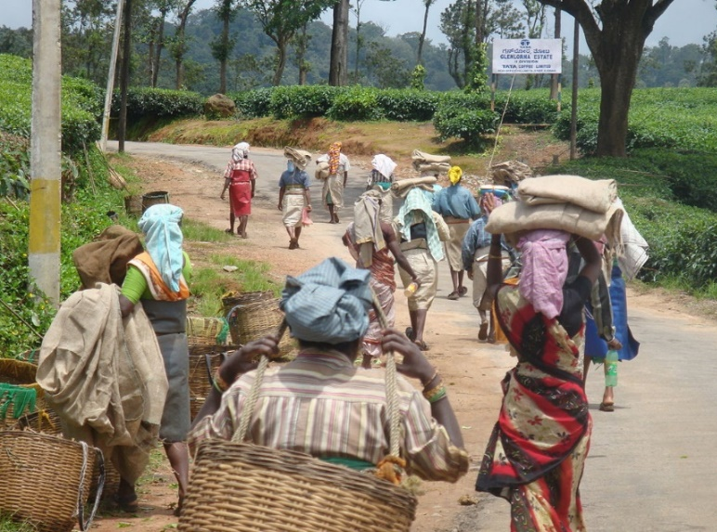
The idea of Fairtrade has been around for a long time. The first ‘Fairtrade’ shop opened in 1958 in the USA, and Oxfam UK started to sell crafts made by Chinese refugees at around the same time. Similar stores began opening around the world, and the big businesses and supermarkets caught on to the idea during the 1990s.

One product you might often see marked as ‘Fairtrade’ is coffee. It is one of the UK’s most popular drinks, and 125 million people around the world depend on its production for their livelihood. It is a sad state of affairs that most of the time, farmers are paid very little for their coffee, despite it being sold for a great deal more afterwards.

With Fairtrade, producers are guaranteed a minimum price for their coffee, which will cover their costs as well as let them invest back into their businesses, improving the quality of their product and the production process. For many workers in developing countries, it means the difference between living in poverty and looking forward to a sustainable future.

Fairtrade fortnight starts on the 25th February. This is a chance for all of us, from consumers to business owners, to really show support for Fairtrade farmers and the Fairtrade idea. Although of course, this isn’t just something we should be doing for a fortnight each year – it’s a great way of raising awareness and kick-starting better buying habits.



