I do | We Do | You Do
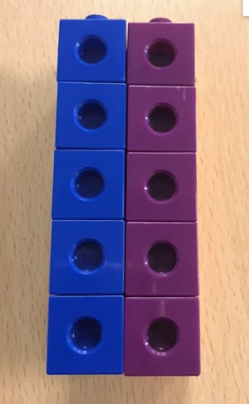  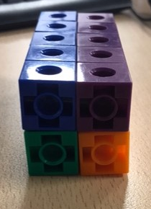  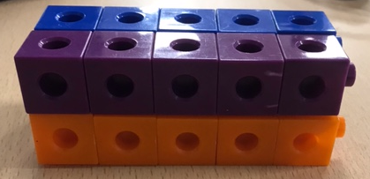 | Why did I count then write 5cm, then 2cm and then 2cm again?  _____________________________  _____________________________  _____________________________  What did I do with those numbers?  _____________________________  _____________________________  _____________________________  What strategy did I use and why?  _____________________________  _____________________________  _____________________________  Why did I write cm³ and not cm²?  _____________________________  _____________________________ _____________________________ | Identify the width, length and height of the cuboid in front of you.  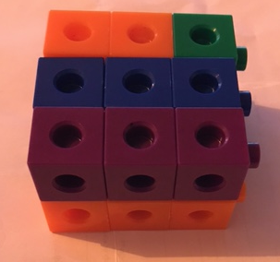  Then calculate the volume.  Write your calculation and answer below.

