First powered flight EVER on another planet
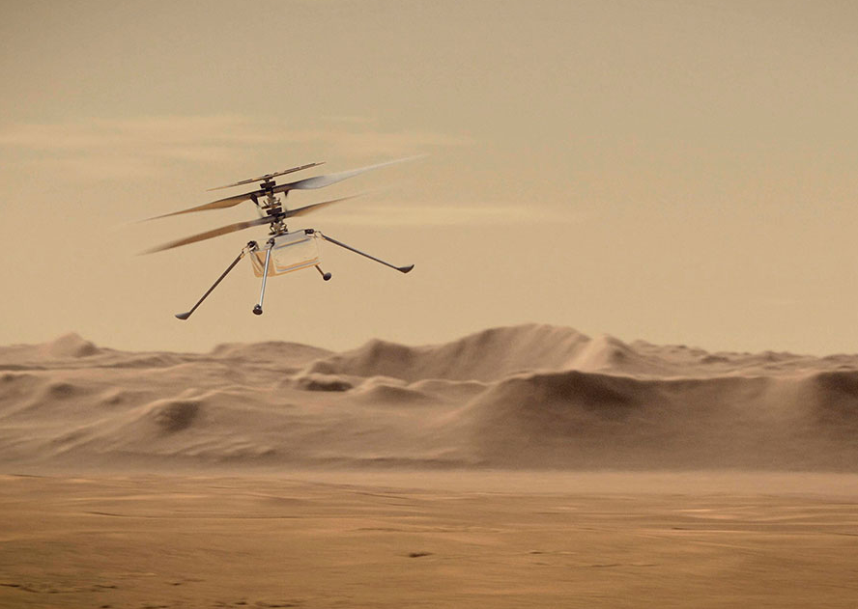
Do humans have a right to be on Mars? Elon Musk talks about colonising the Red Planet. And most people think there’s nothing wrong with exploration. But some are deeply worried.
The tension in the room was palpable. A dozen figures in orange T-shirts sat at their desks, their eyes fixed on a giant screen. Lines of data tumbled down it – and then, at last, came an image: a black angular shape against a grey background. It was what the team had worked towards for six years: confirmation that a helicopter had flown on Mars.
What the photograph showed was the shadow of Ingenuity falling on the Martian surface. A couple of minutes later came video footage from the Mars rover Perseverance showing the helicopter taking off, hovering and landing. The control room exploded with jubilation: the slogan on the wall, “Dare Mighty Things”, had borne fruit.
The flight had actually taken place earlier in the day, but because of the enormous distance between Mars and Earth – over 178 million miles – the information took four hours to reach the team at NASA’s Jet Propulsion Laboratory. It proved that the tiny helicopter had survived its interplanetary journey intact and was able to perform as it was supposed to.
Though Ingenuity did not travel any distance from the Jezero Crater where Perseverance landed, the stage is now set for exploratory flights across the planet.
According to NASA’s Dr Thomas Zurbuchen: “It opens up new doors,” adding a whole extra dimension to the exploration of other worlds. Having such a craft will make it possible for mission control to scout ahead of manned expeditions and examine places such as deep craters which the Mars rover cannot reach.
But while the scientific community rejoices, others warn that we are in danger of repeating on Mars mistakes that we have already made on Earth. Writing in Slate, Christopher Schaberg argues that key figures in space exploration such as Elon Musk have an “extraterrestrial colonising mindset”.
Schaberg points out a paradox in NASA’s decision to name Perseverance’s landing site after Octavia E Butler. NASA was clearly keen to honour Butler as a leading science-fiction writer who was also a woman from an ethnic minority. But Butler’s novels are notable for questioning the morality of claiming other planets for the human race.
Schaberg maintains that “Even though there are no humans yet on Mars, a pattern of entitlement via science is being established.” The more we become accustomed to the idea that colonisation is possible, the more we behave as if the planet were an extension of Earth:
“With each landing site, discarded parachute, cast-off heat shields and other debris on the surface, with all the innumerable images shared on Instagram… with every drone flown (or lost) and each bit of dust gathered for later examination, humans are continuing the fraught practice of acting as if we can and should go wherever we want, take whatever we please, send back postcards… and leave behind our trash.”
Do we have the right to be on Mars?

The urge to conquer
Some say, yes. Comparing the exploration of Mars to historical colonisation on Earth is a false analogy because Mars, as far as we can make out, is uninhabited. Creating settlements there would be beneficial to us without harming anyone else. We should simply celebrate the achievement of getting there as another amazing example of what humanity can do.
Others argue that, having behaved so irresponsibly on our own planet, the last thing we should be doing is exporting our acquisitive values to other worlds. We should concentrate on trying to save Earth’s environment before looking further afield. We may regard Mars as uninhabited and inhospitable, but it has a functioning ecosystem which should be respected rather than interfered with.

