We all speak a little bit of Arabic
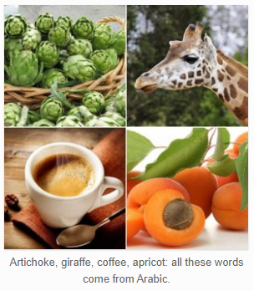
There are many Arabic words in English that we use every day without being aware of their origin. Their presence in English shows how words have travelled with people and products over the centuries. These words belong to English as much as words borrowed from any other language. Apart from words that are simply Arabic names for cultural items or ideas, such as caliph, mosque and sheik, etc., there are several common English words of Arabic origin that we use every day.
Most of these Arabic words in English came in through other languages, mostly French, Italian and Spanish, where similar looking and sounding cognate words are common among them. For example, the word for coffee is caffè in Italian and café in Spanish and French. Also, there are many words of Arabic origin in modern Spanish, which come from the Arab presence in Iberia which ended in 1492.

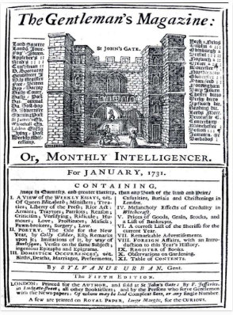
The word “magazine” is a good example of how a word’s meaning can evolve while the word migrates over a wide area and over a long time. The Italian word for a warehouse or storehouse, magazzino, comes from the Arabic makhazin, and was first recorded in Italian in the 14th century. From Italian it entered French as magasin, where today it means a shop. It is recorded in English as a storehouse in the late 16th century. Its English meaning as a periodical publication is first recorded in January of 1731, with the appearance of the first edition of “The Gentlemen’s Magazine” in London.
The moral of this story is that among the peoples of the earth we are closer to each other than we normally realize, and the factors that unite us may be hidden but they are strong. Remember that the next time you are drinking a coffee, eating an artichoke, sitting in an alcove or wearing a cotton shirt.
∞∞∞∞∞∞∞∞∞∞∞∞∞∞∞∞∞∞∞∞∞∞∞∞∞∞∞∞∞∞∞∞∞∞∞∞∞∞∞∞∞∞∞
Here are some of the most frequently used Arabic words in English:
Military terms:
admiral, from amir al-bahr, commander of the sea, أميرال
arsenal, from dar al-sina’ah, a house of manufacturing.
Products of commerce:
amber, from anbar,
cotton, from qutn, قطن
henna, from h’enna’, الحناء
jar, from jarrah, a large ceramic vase, جرة
tariff, from ta’rif, notification, تعريفة.
Animals:
camel, from jamal, جمل
gazelle, from ghazal, غزال
giraffe, from zaraafa زرافة
Apart from Arabic names for Middle-Eastern foods, like tabouleh and hummus, there are many modern English words of Arabic origin for common foods:
These are plant foods:
alfalfa, from al fasfasa, the forage plant;
apricot, from al burquq;
artichoke, from al kharshuf;
coffee, from qahwah; قهوة
carob, from kharrubah; خروب
jasmine, from yasmin; ياسمين
saffron, from zafraan; زعفران
spinach, from isfanakh;
tamarind, from tamr hindi (date of India);
tangerine, from tanja, the name of the city of Tangiers.
These are recipies:
candy, from quand;
sherbet, from sharbah or sharabat; شربات
syrup, from sharab;

