Opening  Introduce the Main Character. | 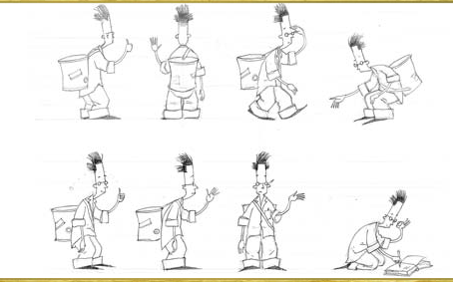 | ______________________________________ ______________________________________ ______________________________________ _______________________________________  _______________________________________
Build-Up  Main Character goes somewhere and finds a lost thing. | 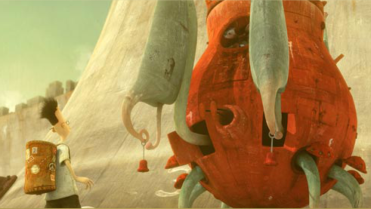 | ______________________________________ ______________________________________ ______________________________________ _______________________________________  _______________________________________
Main Event  Main Character tries to find where the lost thing came from. | 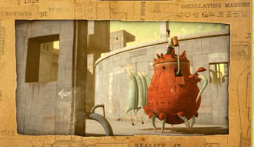 | ______________________________________ ______________________________________ ______________________________________ _______________________________________  _______________________________________  _______________________________________
Resolution  The Main Character and the lost thing find Utopia. | 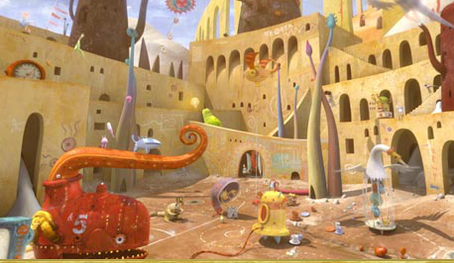 | ______________________________________ ______________________________________ ______________________________________ _______________________________________
Ending  The Main Character goes back to his ordinary life. |      

