1. Write a step-by-step guide on how to position a protractor ready to measure an angle.
You are writing these instructions for someone who has never used a protractor before.
e.g First you need to……..
After that ……
Make sure………

2. Miss Rhodes has positioned her protractor ready to measure an angle.
Explain her mistake!
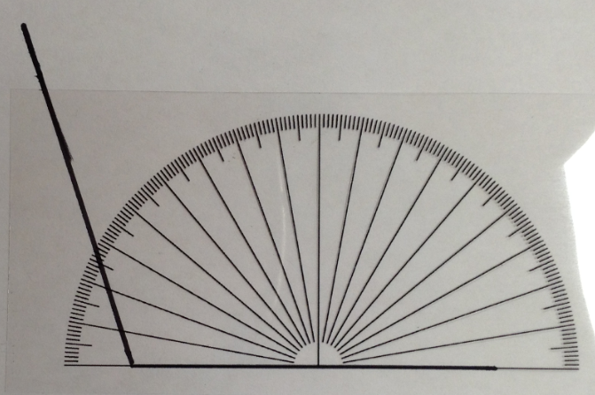

1. Write a step-by-step guide on how to position a protractor ready to measure an angle.
You are writing these instructions for someone who has never used a protractor before.
e.g First you need to……..
After that ……
Make sure………

2. Miss Rhodes has positioned her protractor ready to measure an angle.
Explain her mistake!

