What is trade?
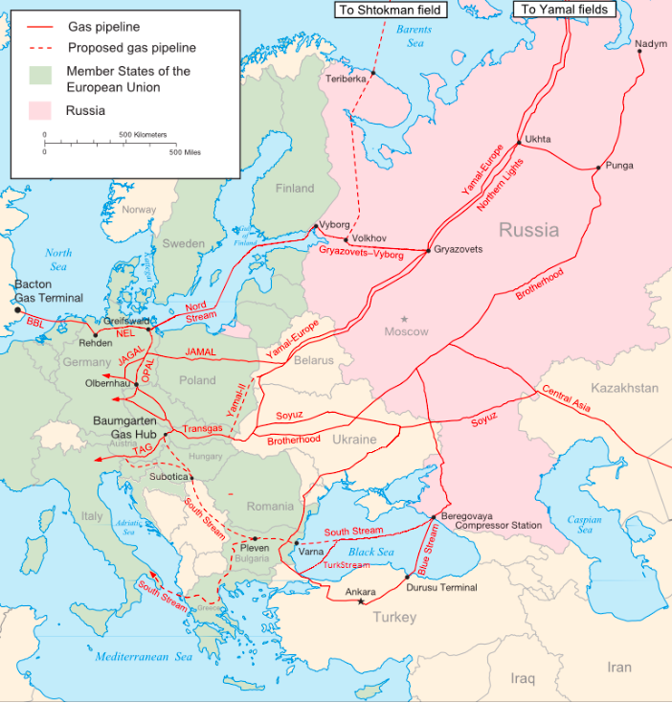
When we make things in one country and sell them in another, it’s called export. We are able to export the things we make when other people in other countries want to buy them. Sometimes this is because they can’t get them from anywhere else and sometimes this is because they’re cheaper or better quality.
There are also things, such as bananas or oranges, that are hard to grow in the UK and we have to buy these things from abroad.
This is called import.
When we buy things from abroad and bring them back home, we are importing them.
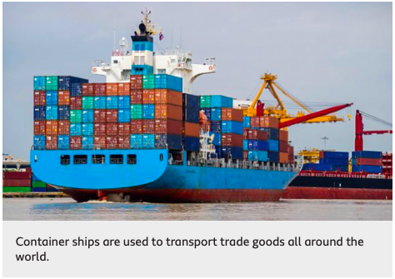
We have been importing and exporting goods between countries for hundreds of years. Buying and selling goods like this is called trade and it’s an important way to make money. Trade happens between businesses and countries like this across the globe.
Container ships and airplanes carry goods like toys, food and even cars from one place to another.
Some countries have rich oil or gas reserves. These goods travel long distances through a system of pipes.
It’s not only goods like these. Sometimes people need experts to help them with things like engineering, banking and even teaching. These experts sell their services to people around the world. These are called service industries.


