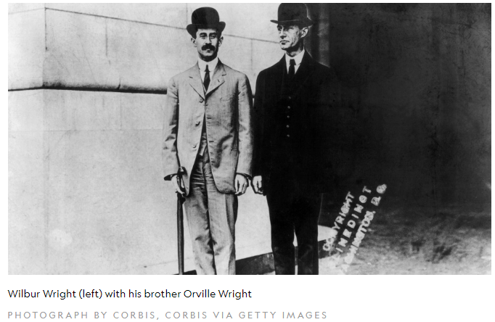
Taking Flight With the Wright Brothers

Find out how these inspiring aviators took to the skies.

It’s a chilly, breezy day in December 1903. Wilbur Wright stands on the beach in Kitty Hawk, North Carolina, staring at the sky above him. Soaring overhead in an airplane is his brother Orville—he’s in the middle of the world’s first successful piloted engine-powered airplane flight.
Today the Wright brothers are remembered as innovative engineers, and their history-making flight inspired generations of future fliers.
The Wright brothers were interested in flying from a young age. As children in Dayton, Ohio, their favourite toy was a small helicopter-like object that was powered by a rubber band to twirl its blades. Fascinated by the toy and its mechanics, the brothers hoped to one day build a flying machine big enough to hold them both.
As young men, the brothers went into business together, first operating a printing press, then a bicycle repair shop. Eventually the duo began selling their own custom-made bicycles to customers.
But the brothers never lost their love of flying. At the time, other aircrafts such as gliders—or aircrafts without engines—did exist, but the Wrights wanted to add more power to the objects they were flying. In 1899 the brothers began experimenting with building their own aircrafts.
UP, UP, AND AWAY
In 1900 the brothers traveled from Ohio to Kitty Hawk, North Carolina, to begin their flight experiments. The oceanside dunes at Kitty Hawk had regular breezes and soft, sandy landing surfaces—perfect for their studies.
The brothers first conducted tests with kites before experimenting with gliders. Both Orville and Wilbur separately piloted the gliders during their testing process.
In 1903 the brothers built an airplane called the Wright Flyer I, which featured wooden propellers the men had designed and carved themselves. The plane also had a gasoline engine.
After weeks of unsuccessful attempts, the craft—with extra fabric incorporated to increase the stiffness of the wings—took flight for 12 seconds on December 17, 1903, traveling 120 feet before landing. The plane worked! Both brothers flew the craft a few more times that day. They had flown the world’s first successful piloted engine-powered airplane.

WINGS OF CHANGE
After their success in North Carolina, the Wright brothers continued to travel around the world, perfecting their craft and modifying their designs. But they did so much more, kicking off the era of modern aviation and inspiring future adventurers.
The decades following Kitty Hawk were filled with accomplishments in aviation, including the first solo flight across the Atlantic Ocean and the first passenger flight. And, of course, flight didn’t just stay in this world—a little over 65 years after the Wrights’ famous first flight, astronauts Neil Armstrong and Buzz Aldrin walked on the moon. The Wright brothers didn’t just fly the first piloted engine-powered airplane—they created a whole new way for us to explore our world.

