A toy costs £6. On Black Friday Sale, a shop makes £1062 from selling the toy. How many toys were sold? | A group of 3 friends take go on a holiday to Spain. The total cost of the holiday is £3492. The friends share the cost equally. How much does each person pay?
Sally is paid £9 per hour.  She was paid £1,890 in for the work she did in November.  How many hours did Sally work in November? | Daisy is buying rulers.  She has £10. Each ruler costs 7p.  Daisy buys as many rulers as she can.  (a) How many rulers does Daisy buy?  (b) How much change should Daisy receive?
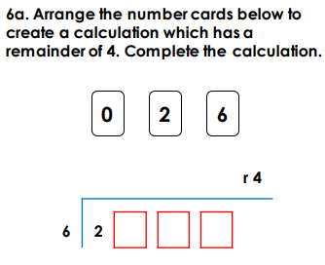 | 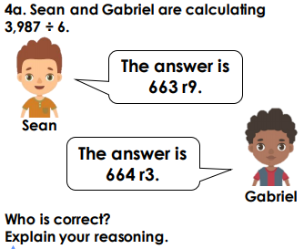
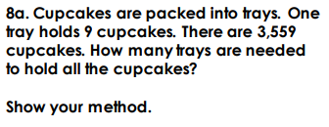 | 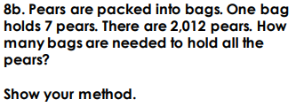
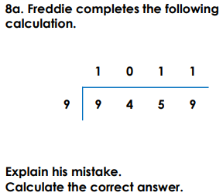 | 

