Great Britain at the Olympics

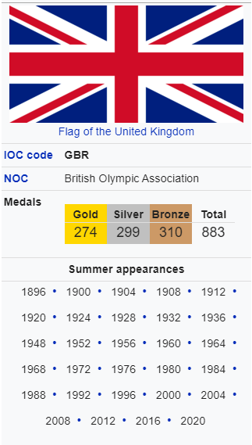
Great Britain at the Olympics is a history which includes 50 games in 24 countries and 7,000+ athletes. Since 1896, sportsmen of the United Kingdom have taken part the growth of the "Olympic Movement".
The International Olympic Committee's official abbreviation for Great Britain is GBR
The British National Olympic Committee was formed in 1905. It was recognized by the International Olympic Committee in 1905.
Great Britain's team first competed at the 1896 Summer Olympics in Berlin.
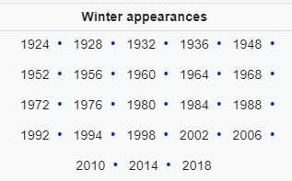
Great Britain is the name that the United Kingdom of Great Britain and Northern Ireland uses when it competes at the Olympic Games. Great Britain was one of 14 teams to compete in the first Games in 1896. It has competed at every Games. As of 2016, Athletes from Great Britain have won 883 medals at the Summer Olympic Games. They have won 22 at the Winter Olympic Games. Great Britain is the only team to have won at least one gold medal at every Summer Games.
Great Britain was the name given to the United Kingdom team for the 1908 Summer Olympics. It was also given the IOC country code GBR. The team is also called "Team GB". Representatives of the devolved Northern Ireland government, do not think this is a good name. They think it suggests that Northern Ireland is not part of the British Olympic team, and they think the name should be changed to Team UK. However, British is a correct term for the United Kingdom of Great Britain and Northern Ireland as, for instance, in "the British Government".
In an agreement between the British and Irish Olympic groups, athletes from Northern Ireland can choose to be a part of the Irish Olympic team. All British people may have dual citizenship if they wish.
Summer Games results
Games | Competitors | Gold | Silver | Bronze | Total | Rank
1896 Athens | 8 | 2 | 3 | 2 | 7 | 5
1900 Paris | 103 | 15 | 6 | 9 | 30 | 3
1904 St. Louis | 3 | 1 | 1 | 0 | 2 | 6
1908 London (host nation) | 676 | 56 | 51 | 39 | 146 | 1
1912 Stockholm | 293 | 10 | 15 | 16 | 41 | 3
1920 Antwerp | 204 | 15 | 15 | 13 | 43 | 3
1924 Paris | 307 | 9 | 13 | 12 | 34 | 4
1928 Amsterdam | 234 | 3 | 10 | 7 | 20 | 11
1932 Los Angeles | 74 | 4 | 7 | 5 | 16 | 8
1936 Berlin | 225 | 4 | 7 | 3 | 14 | 10
1948 London (host nation) | 375 | 3 | 14 | 6 | 23 | 12
1952 Helsinki | 293 | 1 | 2 | 8 | 11 | 18
1956 Melbourne/Stockholm | 200 | 6 | 7 | 11 | 24 | 8
1960 Rome | 252 | 2 | 6 | 12 | 20 | 12
1964 Tokyo | 199 | 4 | 12 | 2 | 18 | 10
1968 Mexico City | 237 | 5 | 5 | 3 | 13 | 10
1972 Munich | 310 | 4 | 5 | 9 | 18 | 12
1976 Montreal | 234 | 3 | 5 | 5 | 13 | 13
1980 Moscow | 222 | 5 | 7 | 9 | 21 | 9
1984 Los Angeles | 355 | 5 | 11 | 21 | 37 | 11
1988 Seoul | 382 | 5 | 10 | 9 | 24 | 12
1992 Barcelona | 389 | 5 | 3 | 12 | 20 | 13
1996 Atlanta | 303 | 1 | 8 | 6 | 15 | 36
2000 Sydney | 320 | 11 | 10 | 7 | 28 | 10
2004 Athens | 270 | 9 | 9 | 12 | 30 | 10
2008 Beijing | 313 | 19 | 13 | 15 | 47 | 4
2012 London (host nation) | 541 | 29 | 17 | 19 | 65 | 3
2016 Rio | 366 | 27 | 23 | 17 | 67 | 2
2020 (2021) Tokyo | 376
Total | 7322 | 236 | 272 | 272 | 780

