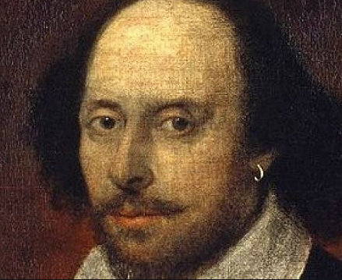
William Shakespeare

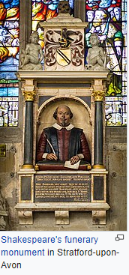
William Shakespeare ( baptised 26 April 1564 – 23 April 1616) was an English playwright, poet, and actor, widely regarded as the greatest writer in the English language and the world's greatest dramatist (a person who writes plays). He is often called England's national poet and the "Bard of Avon". His surviving works consist of 39 plays, 154 sonnets, three long narrative poems and several other poems. His plays have been translated into every major living language and are performed more often than those of any other playwright. They also continue to be studied and reinterpreted.

Shakespeare was born in Stratford-upon-Avon. When he was 18 he married Anne Hathaway who was much older. They went on to have three children: Susanna, Hamnet and Judith (who were twins). His successful career took off in 1585 -1592 where he was an actor, writer and part owned a company of actors called Lord Chamberlain’s Men, which was later known as The King’s Men. Around 1613, Shakespeare is thought to have retired back to Stratford at the age of 49. He died three years later.

Shakespeare produced most of his known works between 1589 and 1613. His early plays were primarily comedies and histories and are regarded as some of the best work produced in these genres. He then wrote mainly tragedies until 1608, among them Hamlet, Romeo and Juliet, Othello, King Lear, and Macbeth, all considered to be among the finest works in the English language. In the last phase of his life, he wrote romances and collaborated with other playwrights.

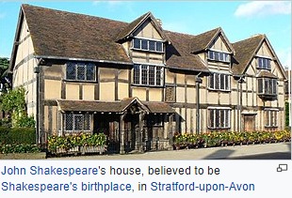

Facts and Rumours


