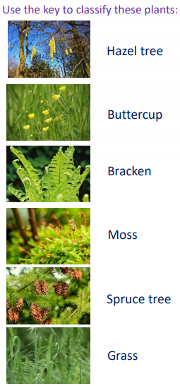
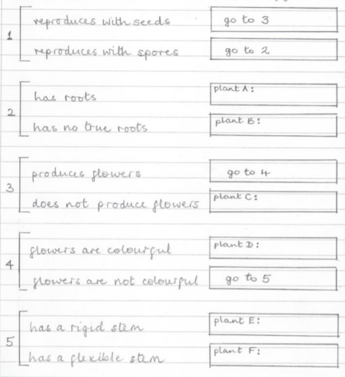

Bracken. It is a fern. It reproduces with spores. It has roots, stems and leaves.
Moss. Moss reproduces with spores. It has no true roots and usually grows in damp, shady places.
Spruce Tree. It does not produce flowers. It has seeds contained in cones.
Buttercup. It has brightly coloured petals that attract insects for pollination.
Hazel Tree. It has catkins as flowers which hang down so the pollen is carried by the wind.
Grass. Grasses usually have dull green or brown flowers and stems which bend in the breeze.

